NORTHERN REGIONAL PLANNING PANEL

Panel Reference | PPSNTH-
DA Number | DA21/0244
LGA | Tweed Shire
Proposed Development | Alterations and additions to the existing Tweed Heads South Public School
Street Address | 4-10 Heffron Street, TWEED HEADS SOUTH
Applicant/Owner | Department of Education
Date of DA lodgement | 26 April 2021
Number of Submissions | One public submission was received in relation to the subject application.  A submission was received from the following Public Authorities:  Essential Energy - Clause 45 of the SEPP (Infrastructure) 2007;  NSW Rural Fire Services – Clause 4.14 of the EPA Act 1979 (Crown development is exempt from being integrated as per Clause 4.44(2) and Division 4.6 of the Act and Part 13 of the Regulations.; and  Transport for NSW - Clause 57 of the SEPP (Education) 2017.  A submission was also received from:  The Tweed Byron Local Aboriginal Land Council (clause 5.10 of the Tweed LEP 2014)
Recommendation | Approval with conditions
Regional Development Criteria  (Schedule 7 of the SEPP (State and Regional Development) 2011) | Crown development that has a capital investment value of more than $5 million.  The Development has a capital investment value of $6,472,610.00.
List of All Relevant s4.15(1)(a) Matters | - List all of the relevant environmental planning instruments: s4.15(1)(a)(i)  SEPP No. 55 - Remediation of Land  SEPP (Coastal Management) 2018  SEPP (Infrastructure) 2007  SEPP (Education and Childcare) 2017  SEPP (State and Regional Development) 2011  SEPP (Koala Habitat Protection) 2020  Tweed Local Environmental Plan 2014  - List any relevant development control plan: s4.15(a)(iii)  Tweed DCP Section A2 – Site Access & Parking Code  Tweed DCP Section A3 - Development of Flood Liable Land  Tweed DCP Section A11 - Public Notification of Development Proposals (now repealed by the Tweed Community Engagement and Participation Plan)  Tweed DCP Section A15 – Waste Minimisation & Management  Tweed DCP Section A16 – Preservation of Trees or Vegetation  Tweed DCP Section B2 – Tweed City Centre
List all planning legislation requirements that the consent authority must consider | - Clause 7 of SEPP55 - Remediation of Land;  - Clause 57 of SEPP (Education) 20 Clause 7 of SEPP55 - Remediation of Land;  - Clause 13, 14, 15 and 16 of the SEPP (Coastal Management) 2018  - Clause 2.3 (2),Clause 7.1(3), Clause 7.2(3), Clause 7.6(3), Clause 7.8 and Clause 7.10 Tweed LEP 2014  All of the applicable consent considerations associated with the abovementioned SEPP's have been addressed within the body of this report.
List all documents submitted with this report for the Panel’s consideration | Section 4.15 Assessment Report including:  - Plans (within report)  - Attachment 1 – Site Photos  - Attachment 2 - written request for a contravention to a development standard (clause 4.6 of the LEP)  - Attachment 3 - submission
Report prepared by | Lydia Charman (Town Planner Development Assessment)
Report date | 8 December 2021

Summary of s4.15 matters  Have all recommendations in relation to relevant s4.15 matters been summarised in the Executive Summary of the assessment report? | Yes
Legislative clauses requiring consent authority satisfaction  Have relevant clauses in all applicable environmental planning instruments where the consent authority must be satisfied about a particular matter been listed, and relevant recommendations summarised, in the Executive Summary of the assessment report?  e.g. Clause 7 of SEPP55 - Remediation of Land, Clause 4.6(4) of the relevant LEP | Yes
Clause 4.6 Exceptions to development standards  If a written request for a contravention to a development standard (clause 4.6 of the LEP) has been received, has it been attached to the assessment report? | Yes
Special Infrastructure Contributions  Does the DA require Special Infrastructure Contributions conditions (S7.24)?  Note: Certain Das in the Western Sydney Growth Areas Special Contributions Areas may require specific Special Infrastructure Contributions (SIC) conditions | No
Conditions  Have draft conditions been provided to the applicant for comment?  Note: in order to reduce delays in determinations, the Panel prefer that draft conditions, notwithstanding Council's recommendation, be provided to the applicant to enable any comments to be considered as part of the assessment report | Yes

Assessment Report and Recommendation

FILE NO: DA21/0244

REPORT TITLE:

Development Application DA21/0244 for alterations and additions to existing educational establishment (NRPP) at Lot 1 DP 517503; Kirkwood Road TWEED HEADS SOUTH; Lot 2 DP 517503; Minjungbal Drive TWEED HEADS SOUTH; Lot 219 DP 755740; No. 4-10 Heffron Street TWEED HEADS SOUTH; Lot 1 DP 781510; Oxley Street TWEED HEADS SOUTH

SUMMARY OF REPORT:

Council is in receipt of a proposed development application seeking consent for alterations and additions to the Tweed Heads South Public School (THSPS).

The proposal seeks consent for the:
- Demolition of Building C and D and ancillary structures;
- Construction of two (2) new buildings, walkways and external staircase;
- Landscaping and tree removal;
- Amendments to pedestrian entrances;
- Relocation of the kiss and drop off functionality

The development will result in an increase in student enrolment capacity to accommodate future growth.
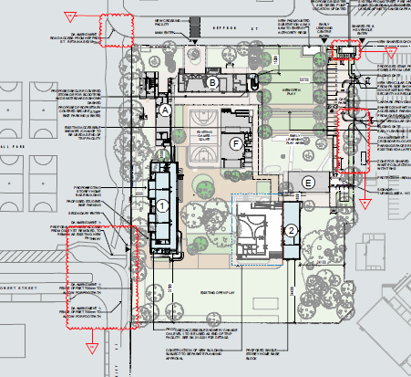
Figure 1: Location and scope of works (source: Submitted DA Plans (amended) by Cottee Parker)

The applicant’s Statement of Environmental Effects (SEE) advises that “The proposed single and two storey buildings are considered to be of a bulk and scale that is commensurate with the existing school buildings and surrounding built form to the north and south. The proposed new buildings and ancillary works will support the growing requirement for educational providers in the north coast region as well as the proposed increase in the operating capacity of the school for up to 500 students. The increase in the school’s operating capacity is not expected to result in adverse traffic or local congestion impacts as the existing onsite parking spaces, bus zones and kiss and ride zones are considered to generally function more than adequately”.

The development has an estimated cost of $6,472,610 excluding GST.

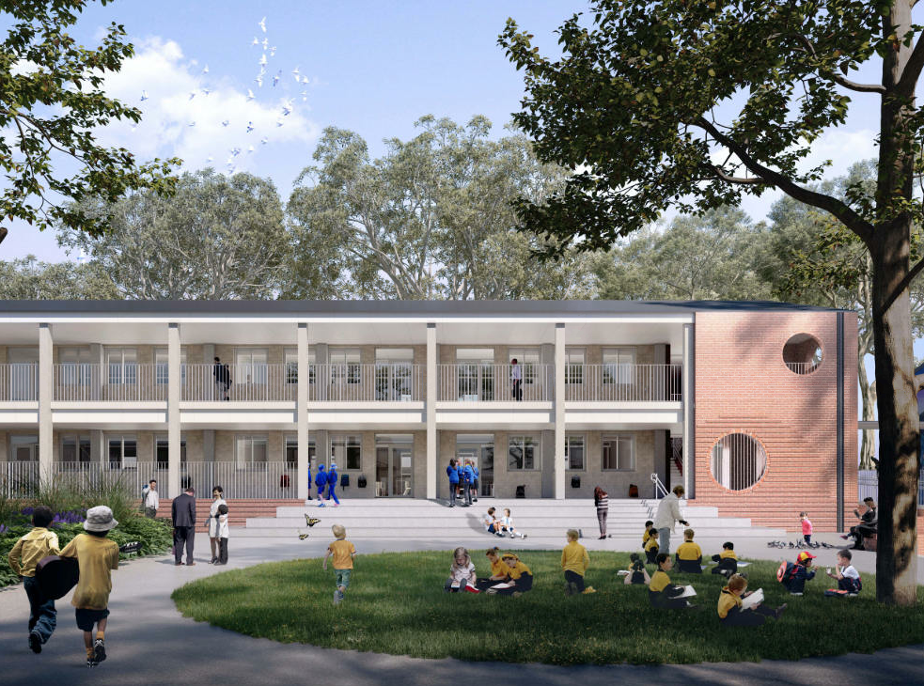
Figure 2: Artists Impression of proposed Building 1 (source: SJB DA Plans)

Existing Development:

The THSPS site is currently comprised of seven (7) buildings, open space/playground area and onsite parking, as follows:

- Building A (administration and staff facilities and (two) x Homebase’s);
- Building B (canteen, student amenities and (four) x Homebase’s);
- Building C (student staff and amenities, learning support, staff education facilities and (three) Homebase’s);
- Building D (library and special classroom facilities);
- Building E (early learning unit) and F (communal hall and covered outdoor learning area);
- Building F (communal hall and covered outdoor learning area); and
- Outside School Hours Care (OSHC).

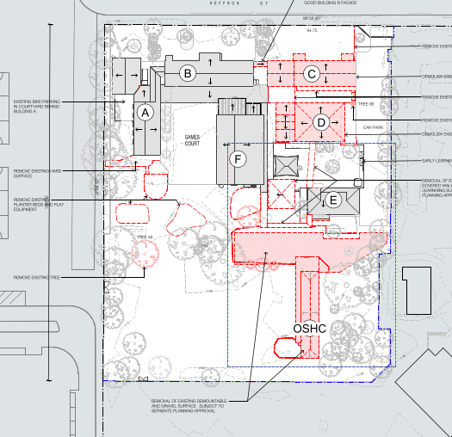
Figure 3: Building to be demolished – (source: submitted DA Plans by SJB Architects)

Proposed development:

Demolition includes:
- Demolition of Building C (student staff and amenities, learning support, staff education facilities and four homebases);
- Demolition of Building D (Library and special classroom facilities) and ancillary structures;
- Demolition/removal of nominated hard surfaces, failing bitumen and gravel to the south of Building A and west of Building F;
- Remove and relocate existing play equipment and raised planter beds;
- Demolition of internal fence to the south of Building F;
- Demolition of bridge connection between Building B and Building C and make good façade of Building B.

The removal of the OSHC demountable and gravel surface is not subject to this application.

New buildings/works includes:
- New two (2) storey building (Building 1) comprising 8 x homebases, amenities and connection to existing Building A;
- Construction of ground floor covered walkway connection between proposed Building 1 and existing Building A;
- New one (1) storey building (Building 2) comprising 3 x homebases, practical activities area and quiet space (withdrawal). The building will be attached to the future library along the western elevation. The future library is subject to a separate planning approval and does not form part of this application;
- Construction of external staircase to existing Building B (canteen, student amenities and 4 x homebases); and
- Minor landscaping works and tree removal

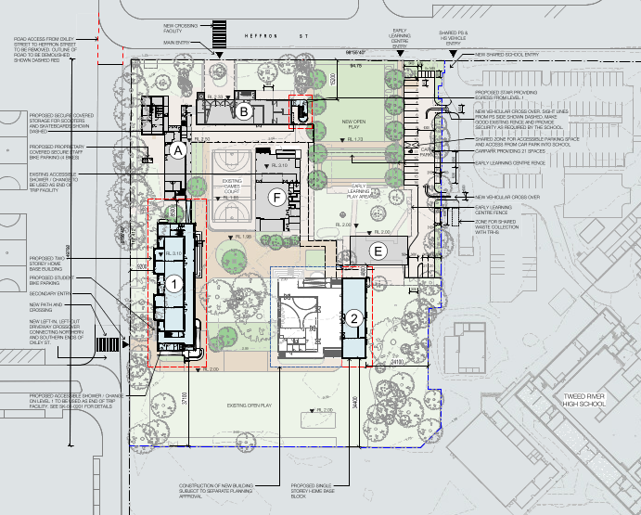
Figure 4: THSPS - proposed works (source: submitted DA plans SJB Architects)
The application also includes works within the Oxley Street and Heffron Street Road Reserves. These works have been considered in support of the subject application and will be subject to a S138 application. Owner’s consent has been provided by Council.

The application includes a clause 4.6 variation to the mapped height of building under clause 4.3 of the Tweed LEP 2014.

The height of a building on any land is not to exceed the maximum height shown for the land on the Height of Buildings Map, which for the subject site is 9.0m from existing ground level. The proposed development has a maximum height of 10.146m. The proposal therefore seeks a clause 4.6 Variation to this clause.

The applicant has advised the following with this regard:

The proposed variation to the height standard is considered appropriate for the following reasons:

- The variation to the height control is a direct outcome of the site being located within the Tweed Valley Floodplain. This requires any new building to provide a minimum floor level of 2.6m AHD + 500mm freeboard so that it is above the 1 in 100 flood events. This results in the ground floor of the proposed Building 1 being elevated up to 1.29m above the existing ground level on site.

- The roof of the new two (2) storey building has shallow pitch of 16 degrees which responds to the other school buildings on site and roof pitch of surrounding residential dwellings to the north and south. To achieve compliance with the height control, the roof pitch would need to be lowered to less than 5 degrees and replaced with a single skillion roof. A skillion roof form is not consistent with the predominant school buildings that are being retained. A skillion roof is also a less sustainable option as natural ventilation and cooling of the building would be reduced due to the limited roof space between the ceiling and roof.

The application has been supported by a written request for a contravention to a development standard, which has been provided as attachment 2 to this report.

The variation is addressed further under the Clause 4.6 assessment of this report.

The proposed development was lodged on 26 April 2021 and was advertised and notified to adjoining and nearby properties for a period of 14 days from Wednesday 19 May 2021 to Wednesday 2 June 2021. A single submission was received from the general public.

The application was referred to NSW Essential Energy, NSW Rural Fire Services, Transport for NSW and the Tweed Byron Local Aboriginal Land Council. Comments from these agencies are discussed in detail later in the report.

Council’s initial assessment sought further detail from the applicant in relation to a number of elements including, removal of Koala Food Trees (in particular associated with the nominated kiss and drop), Construction Management, Acid Sulfate Soils, Lighting, Noise, contamination, dewatering and Aboriginal and Cultural Heritage.

A response was received by the applicant in relation to all matters raised by Council. Of particular relevance the location of the kiss and drop area was relocated further south to avoid tree removal. This is discussed further within the background section of this report.

Potential impacts arising from the proposed development include, traffic impacts; noise impacts; visual impacts; impacts upon flora and fauna; stormwater drainage impacts; and impacts upon Council’s wastewater infrastructure.

The proposal was supported by a number of documents including (but not limited to); Architectural Plans, SEPP (Education and childcare) 2017 Design Statement, Traffic Impact Assessment , Arboriculture report, Landscape Plan, Bushfire Risk Assessment, Accessibility report, Aboriginal Cultural Heritage Assessment, Waste Management Report, Flooding Assessment report and a Noise and vibration assessment report and construction management plan. A detailed assessment of the potential impacts associated with the development is provided within the body of this report.

Council’s Development Assessment Unit, Environmental Health Unit, Traffic Engineer Unit, Water and Wastewater Unit, Roads and Stormwater Unit, Development Engineering Unit, Building Unit and Sustainability and Environment Unit have assessed the proposed development with regard to potential impacts arising from the proposed development. No objections were raised by Council officers, subject to the imposition of relevant conditions of consent.

Appropriate conditions of consent have been recommended to ensure that potential impacts arising from the proposed development can be adequately controlled and managed.

There are a number of planning legislation requirements that the consent authority must consider. A detailed assessment of the relevant clauses is noted within the report. A summary is noted below:
- Clause 7 of SEPP No 55 – Remediation of Land. The proponent’s assessment of the subject site concluded that the land is not contaminated and is suitable for the proposed development. Council officers are satisfied that the proposed development meets the provisions of clause 7 of SEPP 55;
- Clause 13, 14, 15 and 16 of the SEPP (Coastal Management) 2018. Clauses 13, 14, 15 and 16 states that consent must not be granted unless the consent authority is satisfied the proposed development will not significantly impact upon: a coastal wetland; coastal environmental area; the coastal use area; or the coastal zone in general. Subject to conditions of consent, Council officers are satisfied that the proposed development meets the provisions of clauses 11, 13, 15 and 16 of the Coastal Management SEPP;
- Clause 45 of the SEPP (Infrastructure) 2007 Clause 45 of the ISEPP states that the consent authority must provide written notice to the electricity supply company and take into consideration any response. The provisions of clause 45 have been met, as the application was referred to Essential Energy and appropriate conditions applied based on their response.
- Clause 57 of the SEPP (Educational Establishments and Child Care Facilities) 2017. Clause 57 requires the consent authority to consider accessibility of the site as well as traffic / transport impacts associated with the development. The subject application does not increase student numbers, accordingly, is not considered as traffic generating development under Clause 57 of the Educational Establishments and Child Care Facilities SEPP;
- Clause 2.3 (2) of the Tweed LEP 2014 - Zone objectives and Land Use Table. This clause advises that the consent authority must have regard to the objectives for development in a zone when determining a development application in respect of land within the zone. The subject application has considered the zone, is permissible with consent and meets the aims of the R2 zone;
- Clause 7.1(3) of the Tweed LEP 2014 – Acid Sulfate Soils. This clause advises that consent must not be granted under this clause for the carrying out of works unless an acid sulfate soils management plan has been prepared for the proposed works in accordance with the Acid Sulfate Soils Manual and has been provided to the consent authority. A Detailed Site Investigation for Tweed River High School, 12-16 Heffron Street, Tweed Heads prepared by Douglas Partners Pty Ltd dated 5 October 2021 (Project 97611.00, Revision 4, Document No: R.006.Rev3) has been submitted with the application and supported by Councils Environmental Health Unit;
- Clause 7.2(3) of the Tweed LEP 2014 – Earthworks. Clause 7.2(3) requires the consent authority to consider effects and potential impacts on the site and surrounding locality as a result of the proposed earthworks. The earthworks associated with the subject application are considered minor. Council officers are satisfied that the proposed development meets the provisions of clause 7.2(3) of the Tweed LEP 2014;
- Clause 7.6(3) of the Tweed LEP 2014 – Stormwater management. This clause advises that consent must not be granted to development on land to which this clause applies unless the consent authority is satisfied that the development will have adequate stormwater management. Subject to conditions applied, the proposed development meets the provisions of Clause 7.6; and
- Clause 7.8 of the Tweed LEP 2014 – Airspace Operations. Clause 7.8(3) states that the consent authority must be satisfied that the proposed development will not penetrate the Gold Coast Airport’s Obstacle Limitation Surface (OLS). The site is within the 49.5m Inner Horizontal OLS. The site has a natural ground level at the highest point of 2.0m. The development has a maximum height of 8.326m. Council officers consider that the provisions of Clause 6.9(3) have been met.
- Clause 7.10 of the Tweed LEP 2014 – Essential Services. Clause 7.10 requires the consent authority to consider essential services for the proposed development. Subject to conditions of consent, Council officers are satisfied that the proposed development meets the provisions of clause 7.10 of the Tweed LEP 2014.

The proposed development is permissible with consent in the R2 Low Density Residential zone under TLEP 2014, and is consistent with the broad objectives of the zone. The development complies with the maximum floor space ratio (FSR) of 0.8:1, which is applicable to this site under Tweed Local Environmental Plan 2014 (TLEP 2014), however one of the new buildings results in a breach of the 9m TLEP 2014 height limit. The height non-compliance is minor and can be attributed to an elevated floor level to responded to the site mapped flood level The extent of the height non-compliance is limited to the ridge of the pitched roof, which is approximately16 degrees and a similar roof pitch and scale to the other buildings on site.

In summary, the assessment of the proposed development has adequately addressed all consent considerations required by the abovementioned SEPP’s and LEP clauses. It is therefore considered that the Panel can endorse the clause 4.6 variation and proceed with determining the application, subject to the recommended conditions of consent as the development is consistent with the character of area and provides an essential service to the growing Tweed Heads South population. A single submissions was received in relation to ensuring adequate trees and shading for students. The application is considered to address this appropriately.

In accordance with Clause 4.33 Determination of Crown development applications of the EP&A 1979 Council forwarded a complete suite of draft conditions for DA21/0312 to the applicant/crown for review.

The applicant responded to Council 8 December advising that School Infrastructure NSW are generally in acceptance of the conditions received 7th December 2021.

However, School Infrastructure NSW maintain that Council’s approval of Section 68 applications by the Crown are not required.

Council contends that the imposition of S68 is required and should be retained.

The Section 68 relates to works directly (connecting) or indirectly (working near or over the water unit infrastructure). Until the diversion sewer works are operational the building works has the potential to impact the existing gravity main on site that drains the upstream Council facilities. Accordingly Council has applied the following conditions:

Sewer manholes are present on this site. Manholes are not to be covered with soil or other material.

Should adjustments be required to the sewer manhole, then applications for these works must be submitted on Council's standard Section 68 Application form accompanied by the required attachments and the prescribed fee.

Council is also of the opinion that the imposition of the following condition provides security to the applicant by referencing a diversion concept that will be approved subject to their consultants providing sufficient technical detail provided in the upcoming amended design.

The proposed sewer diversion works shall be generally designed and constructed in accordance with the MDA Consulting Engineers - Hydraulic Services Plan - Drawing MDA-HY-TRHS-0201-RevC . Detailed design information shall be provided to council for the assessment of these sewer diversion works. A Sewer Management Plan shall be submitted to support this application in demonstrating that the existing level of sewer service is maintained during construction. The application shall be submitted on Council's standard Section 68 Application form accompanied by the required attachments and the prescribed fee. The sewer diversion works shall not commence until prior separate approval to do so has been granted by Council under Section 68 of the Local Government Act.

Council advised SINSW during the assessment process that s68’s would still be referenced throughout the consent, once the works had been ‘de-coupled’.

Council has also amended the wording of the section 68 conditions, to ensure that any reference to works is to sewer and infrastructure works only and other works subject to this consent are not held up.

REPORT:

Applicant: Department OF Education
Owner: Department School Education & Training
Location: Lot 219 DP 755740; No. 4-10 Heffron Street TWEED HEADS SOUTH
Zoning: R2 - Low Density
Cost: $6,472,610.00

Background:

The site
The subject site is legally referred to as Lot 219 DP 755740 and more commonly referred to as 4-10 Heffron Street, Tweed Heads South.

The site is regular in shape and has an approximate land area of 5.34HA.

The site (Lot 219) currently comprises the THSPS and the Tweed River High School (TRHS), noting that the TRHS also encompasses Lot 1 DP 517503, Lot 2 DP 517503 and Lot 1 DP 781510. The overall site (all aforementioned lots) has an area of approximately 13.87 hectares.

The THSPS has an area of 1.79 hectares and the TRHS 12.08 hectares:

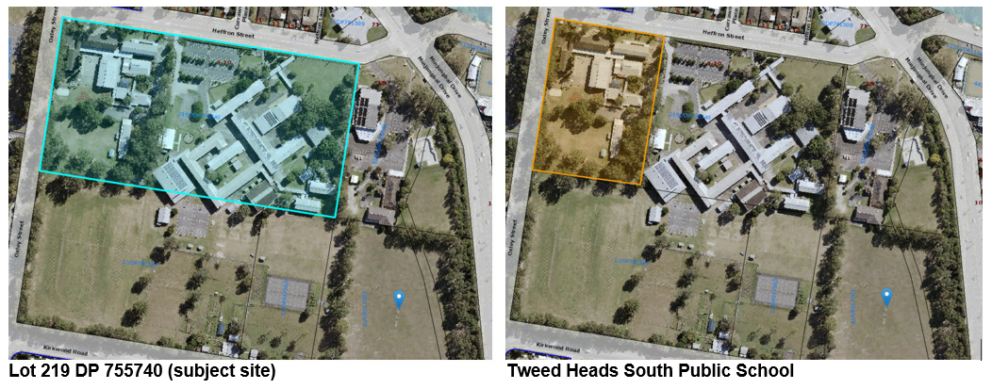
Figure 5: THSPS Site (source: TSC Weave GIS)
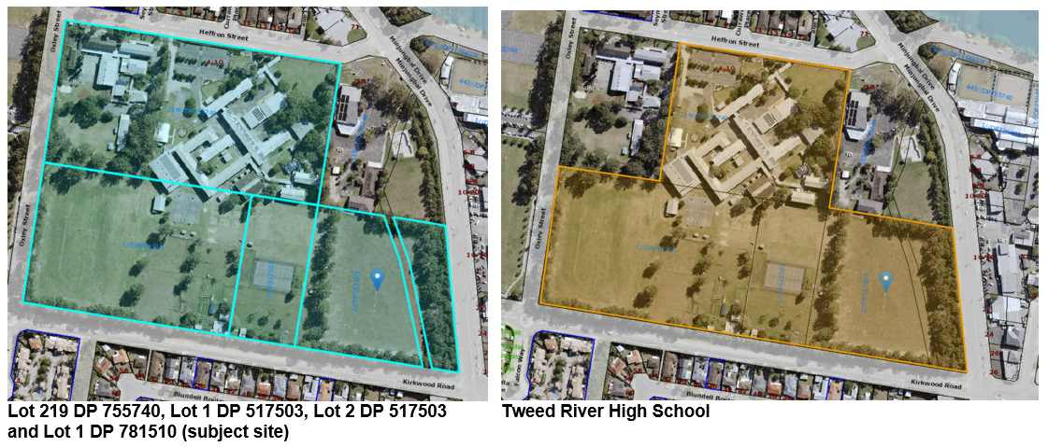
Figure 6: Combined sites (source: TSC Weave GIS)

The site has frontage Heffron Street to the north and Oxley Street to the west. Immediately adjoining the site along the eastern and southern boundaries is Tweed River High School.

As advised above, the THSPS comprises a number of one (1) and two (2) storey buildings, playground and outdoor spaces and onsite parking.

The THSPS site is currently comprised of seven (7) buildings, open space/playground area and onsite parking, as follows:

- Building A (administration and staff facilities and (two) x Homebase’s);
- Building B (canteen, student amenities and (four) x Homebase’s);
- Building C (student staff and amenities, learning support, staff education facilities and (three) Homebase’s);
- Building D (library and special classroom facilities);
- Building E (early learning unit) and F (communal hall and covered outdoor learning area);
- Building F (communal hall and covered outdoor learning area); and
- Outside School Hours Care (OSHC).

The surrounding development is described below:
- Directly north of Heffron Street, the development consists of dwelling houses, interspersed with townhouses and low scale residential flat buildings;
- Further north and to the east past the adjacent Tweed River High School along Minjungbal Drive, the development is characterised by a mix of commercial uses, including a range of retail premises and the Tweed Regional Aquatic Centre, skate park and community building;
- Residential development lies to the south of Kirkwood Road past Tweed River High School playing fields; and
- A tennis academy and playing fields are located to the west, opposite the site on Oxley Street.

The proposal

The proposal seeks consent for the:
- Demolition of Building C and D and ancillary structures;
- Construction of two (2) new buildings, walkways and external staircase;
- Landscaping and tree removal;
- Amendments to pedestrian entrances;
- Amendments to the location of the kiss and drop off functionality; and
- An increase in student enrolment capacity to accommodate future growth.
Demolition includes:
- Demolition of Building C (student staff and amenities, learning support, staff education facilities and four homebases);
- Demolition of Building D (Library and special classroom facilities) and ancillary structures;
- Demolition/removal of nominated hard surfaces, failing bitumen and gravel to the south of Building A and west of Building F;
- Remove and relocate existing play equipment and raised planter beds;
- Demolition of internal fence to the south of Building F;
- Demolition of bridge connection between Building B and Building C and make good façade of Building B.

New buildings/works includes:
- New two (2) storey building (Building 1) comprising 8 x homebases, amenities and connection to existing Building A;
- New one (1) storey building (Building 2) comprising 3 x homebases, practical activities area and quiet space (withdrawal). The building will be attached to the future library along the western elevation. The future library is subject to a separate planning approval and does not form part of this application;
- Construction of ground floor covered walkway connection between proposed Building 1 and existing Building A;
- Construction of external staircase to existing Building B (canteen, student amenities and 4 x homebases); and
- Minor landscaping works and tree removal

Operation and enrolment numbers

Following a review of all available records Council was unable to find any restriction on student or staff numbers for the primary school in previous consents.

The applicant’s SEE advises that the proposal is to upgrade the THSPS to cater for existing enrolments and to accommodate the growing requirement for educational providers in the north coast region.

THSPS has an enrolment capacity of 330 students, however, there are currently approximately 250 students. While SINSW have not identified any growth in the short to medium term (up to 10 years), there is potential growth in the long term (greater than 10 years).

Accordingly, the subject application seeks approval for the maximum operating capacity of the school to allow for long term growth of up to 500 students. This represents an increase of 250 students relative to the existing operations and enrolments and an increase of 170 students compared to the current capacity.

Staff
The SEE advises that an additional seven (7) teaching staff will be required to accommodate the additional classrooms created by proposed Buildings 1 and 2. This represents an increase of 27% relative to the existing number of teaching staff (29), resulting in a total of 36 teaching staff.

Access
Vehicle access is currently provided via Heffron Street towards the eastern side of the site, adjacent to the Tweed River High School (TRHS) vehicular access.

It is proposed to remove the Heffron Street vehicular access (to the staff car parking area) and rely on the TRHS vehicular access. An internal through road from the TRHS side is proposed to connect to the THSPS staff car parking area.

Council supports this option as the amendment will reduce the conflicts between vehicles and pedestrians on the Heffron Street Road Reserve.

With the proposed changes to onsite parking and loading areas all loading and refuse collection will now take place within the TRHS loading area (on the same site).

Swept paths show all servicing and refuse collection vehicles can enter and exit the subject site in a forwards gear while maintaining adequate outer body clearances at all times.

Kiss ‘n’ drop off
The Heffron Street / Oxley Street intersection provides access to the current informal kiss’n’drop area. The current arrangements create a number of safety concerns.

The application as lodged sought consent to close off the Oxley Street/Heffron Street access, with a new access being installed on Oxley Drive/Robert Street for the kiss’n’drop and informal parking area, with a left-in/left-out driveway onto the Oxley Street (south)/Robert Street intersection.

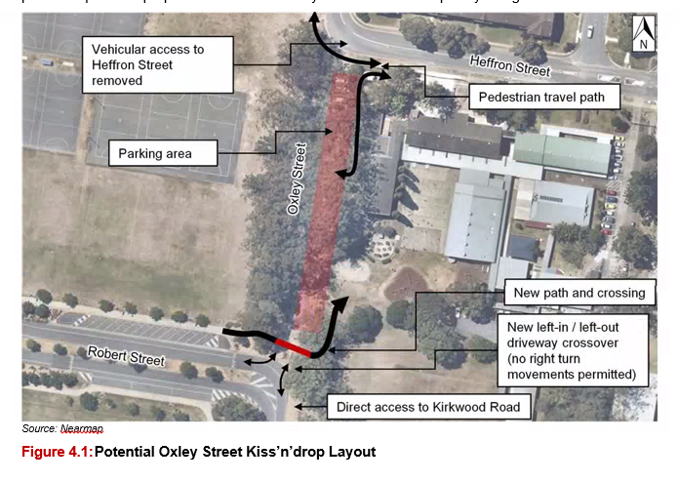
Figure 7: Proposed Kiss'n'drop as lodged Source: Bitzios Traffic Report)
Council agreed that these changes should improve road safety and traffic flow and were supported in-principle. However, it became apparent that there was inadequate width to cater for two-way traffic in some sections without the need for widening and significant tree removal (Koala food trees).

In response to the above in consultation with Council the applicant’s amended the proposed kiss’n’drop to avoid excessive tree removal and triggering offset plantings. It is

The alternate kiss’n’drop arrangement maintains the same vehicle access operations under the original proposal, but proposes to position kiss’n’drop bays further south with vehicles accessing via Robert Street eastbound instead of Oxley Street via the initially proposed u-turn movement within the informal parking area.

The proposed location may result in the removal of a single tree. Council has ensure that were retention is unavoidable offset planting will be required under the Section 138 Application (see recommended condition below).

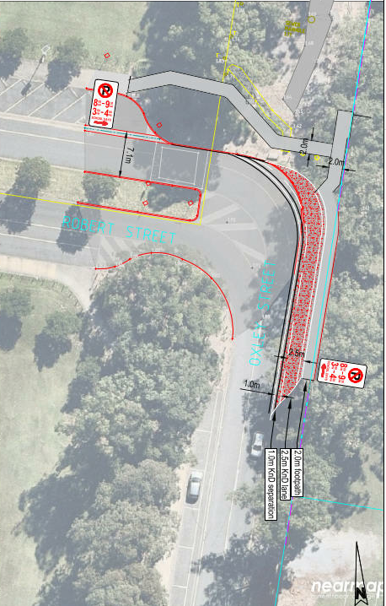
Figure 8: Proposed location of kiss’n’drop (source: Bitzios Traffic Engineering Plans)

The key components are:

- Vehicles will approach the Kiss’n’drop facility eastbound on Robert Street, which connects to Cunningham Street (to the north) and via Oxley Street south to extend to Kirkwood Road. The use of this ‘internal road’ section of Arkinstall Park removes vehicles from the school frontage on Heffron Street and includes roundabouts at either side of the Kiss’n’drop facility to allow vehicles to u-turn and re-circulate if required.
- 3.5m pavement widening and associated spoon drainage to accommodate a 2.5m Kiss’n’drop parking lane and 1.0m through-lane separation
- The Robert Street Kiss’n’drop facility provides 30m (five (5) vehicles) storage length as well as 36m (six (6) vehicles) of queueing length, before the existing angled parking spaces, for a total provision of 11 vehicles.
- Queuing for the Kiss’n’drop facility can accommodate for an additional 80m ( 13 vehicles) back to Robert Street’s internal roundabout adjacent to existing angled parking spaces. This potential queuing operation is consistent with the previous proposal which allowed Kiss’n’drop queuing behind parking spaces. This internal roundabout on Robert Street was designed for U-turn / circulation purposes only as part of the Arkinstall Park Sports Precinct design and does not incorporate any other side street approaches that would introduce a potential conflict point.
- The width of Robert Street pavement is 7.0m and allows sufficient width for a vehicle to pass Kiss’n’drop queueing if required. Attachment 2 demonstrates vehicle queuing as well as 600mm clearance between a queued vehicle and a passing vehicle ( if required). While the school is not proposing any increase in enrolments associated with the application, there is potential for the school in the future to increase up to 500 students.
- In regards to the capacity of the Kiss’n’drop to manage future increases in enrolments, the following is noted:
  - The proposed changes to the Kiss’n’drop operation for the school will be a significant improvement from the existing Kiss’n’drop facility which is a total of 36m in length and located directly adjacent to the bus zone. This facility does not incorporate any queuing capacity and requires vehicles to store along Heffron Street (westbound)
  - The proposal Kiss’n’drop facility and use of Robert Street provides significantly more queuing capacity than the current proposal as described above and also within a more controlled, lower speed road environment which includes speed treatment measures
- The location of the new school entry on the western side of the school is directly adjacent to largely under-utilised ( during pick-up periods) sports precinct parking area which gives parents and guardians a greater opportunity to “Park n Walk” to collect their children, reducing the demands for the Kiss’n’drop both now and as part of further potential enrolment increases at TSPS.

- Provision of a 2.0m wide footpath between the Kiss’n’drop bays and the revised site fence line. This path connects to the new school entry on the western side of the school and allows for students to be stored within school grounds and ‘called-up’ to access vehicles when required
- Provision of a 2.0m wide footpath extension connecting to existing footpath on Robert Street to the new school entry. This pathway further reduces the reliance on pick-up/drop-off demands along Heffron Street and allows enhanced separation of private pick-up/drop from school bus operations
- To accommodate the spatial requirements of the Kiss’n’drop facility and integrate with the existing road form on Oxley Street, the proposal will incorporate approximately 700mm encroachment into the school site. The proposal will realign the fence line to accommodate the Kiss’n’drop facility and include land dedication of Kiss’n’drop land to Council as road reserve

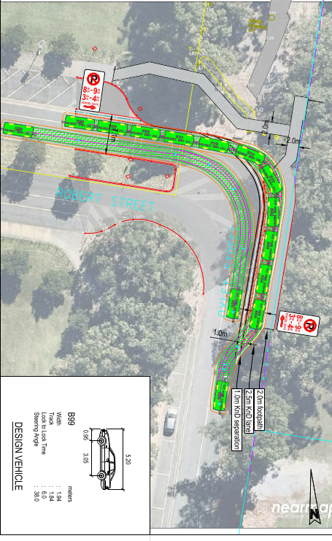
Figure 9: details showing kiss'n'drive allowing through traffic (source: Bitzios Traffic Engineering Plans)

The relocation of the Oxley Street kiss’n’drop access reduces potential for pedestrian and vehicle conflict, increases the safety of vehicle access for kiss/n/drive and also provides an opportunity to increase the length of the bus zone on the Heffron Street frontage, should additional capacity be required. The following works will require approval under a Section 138 application. The following conditions have been applied in this regard:

A Section 138 Roads Act application, with detailed engineering plans, is to be submitted to Council for approval for the following works external to the site:
a. Changes to the western pedestrian refuge in Heffron Street and associated signage and pavement markings
b. All works proposed within Oxley Street and Robert Street for the proposed kiss n drop zone
The application made under the Roads Act 1993 must also include the following:
a. Identification of all trees to be retained and protected within ten metres of the extent of works.
b. Details of tree management measures to be implemented during the construction phase in accordance with Australian Standard AS4970:2009 Protection of trees on development sites.
c. Where tree removal is deemed unavoidable and authorised by Council any tree removed shall be replaced at a ratio of 1:1 (remove to replace) with similar species of minimum 45 Litre stock size in accordance with Council’s Development Design Specification D14.08.03C Tree Planting and Location (for distances away from infrastructure such as light poles and driveways) and Standard Drawing Tree and Shrub Planting Details Dwg. No. SD701 (including the installation of root barrier) to the satisfaction of Councils General Manager or their delegate. Any replacement tree/s shall be installed prior to the operation of the development approved by this consent.
Approval of the Section 138 Application generally in accordance with the civil drawings prepared by ADG, dated 22 October 2021, Rev 1 is subject to the submission of details to the Council for referral to and consideration of the Local Traffic Committee for the proposed changes to the existing pedestrian refuge and all associated signage together with the proposed ‘kiss n drop’ (No Parking) zone.

Dewatering
The site is identified as having High groundwater vulnerability. Section 5.2.1 of the SEE advises “the excavation works to accommodate the footings associated with these buildings will extend 600-700mm below existing ground levels, and thus are highly unlikely to encounter groundwater”. Further, “in the unlikely event the dewatering is required, the dewatering management plan provides two options for disposal of the water. One, the water produced should be temporarily stored on site in holding tanks to allow monitoring of groundwater quality and treatment (as needed) to occur prior to discharge into the local stormwater drainage system with THCC approval. Alternatively, depending on the area available on site, the dewatering effluent could be returned to the ground via a trench, and without treatment. The preferred approach is the first option, being water temporarily stored on site in holding tanks to allow monitoring of groundwater quality and treatment (as needed) to occur prior to discharge”.

The site is generally low lying and groundwater levels can fluctuate. The applicant provided a Groundwater Investigation and Dewatering Management Plan for Tweed Heads South Public School, 4-10 Heffron St, Tweed Heads prepared by Douglas Partners Pty Ltd dated 22 February 2021 (Project No. 97611.00; Document No. R.008.Rev2) in the event that dewatering is required.

The Dewatering Management Plan (DMP) did not meet Council’s standard for reporting on dewatering proposals. Further information was sought with this regard.

A revised Groundwater Investigation and Dewatering Management Plan for Tweed Heads South Public School prepared by Douglas Partners Pty Ltd dated 23 August 2021 (Project No. 97611.00, R.008.Rev3) and supplemental information from the project contractor Lipman dated 24 August 2021 has been submitted that has addressed the information requested above.
As minor excavation is required, offsite dewatering is not anticipated as the groundwater will be pumped back into the ground. However in the event that offsite dewatering is required, a dewatering management plan has been provided and the applicant will seek Council approval prior to discharge. Holding tanks/sediment pond will be provided.
The following conditions have been applied in this regard:

- All works shall be carried out in accordance with the Groundwater Investigation and Dewatering Management Plan for Tweed Heads South Public School prepared by Douglas Partners Pty Ltd dated 23 August 2021 (Project No. 97611.00, R.008.Rev3) or to the satisfaction of Principal Certifier.
- All pumps used for onsite dewatering operations are to be installed on the site in a location that will minimise any noise disturbance to neighbouring or adjacent premises and be acoustically shielded to the satisfaction of the Principal Certifier so as to prevent the emission of offensive noise as a result of their operation.
- All waters pumped from the site in the dewatering process are to be treated with an effective deodoriser to the satisfaction of the Principal Certifier to neutralise any offensive odours.
- The point of discharge for offsite dewatering shall be approved by Council’s General Manager or delegate prior to installation and shall include a water sampling outlet.
- Pumps used for dewatering operations are to be electrically operated. Diesel pumps are not to be used unless otherwise approved by the Principal Certifier.
- The Principal Certifier shall be advised within 24 Hours in the event of detection of any failure associated with the dewatering activity being carried out on the site.

Sewer Infrastructure

Diversion of Upstream Council Sewer
Councils Water unit and the Contractor Lipman/Bennett & Bennett have been in regular contact in generating a mutually agreed solution in diverting the upstream sewer flows, including upstream flows generated from Tweed Shire Council Aquatic and Community Centre facilities. The diversion works are currently subject to assessment of a s68 application - SSW21/0007.

Sewer Works in the Vicinity of the Primary School Building Upgrade.

The W&WWU and Councils Building Unit have issued a number of approvals in the vicinity of this Primary School Upgrade.

These recent approvals have involved the diversion of the existing sewer to facilitate Building 1 and 2 and renovations mains within the Primary School site.

The diversion works for this area was covered off in s68 application - SSW21/0006. It involved 3 “private “ sewer pump stations and retaining elements of the existing gravity sewer on site. An excerpt of those diversion works are shown in Figure 10 below.

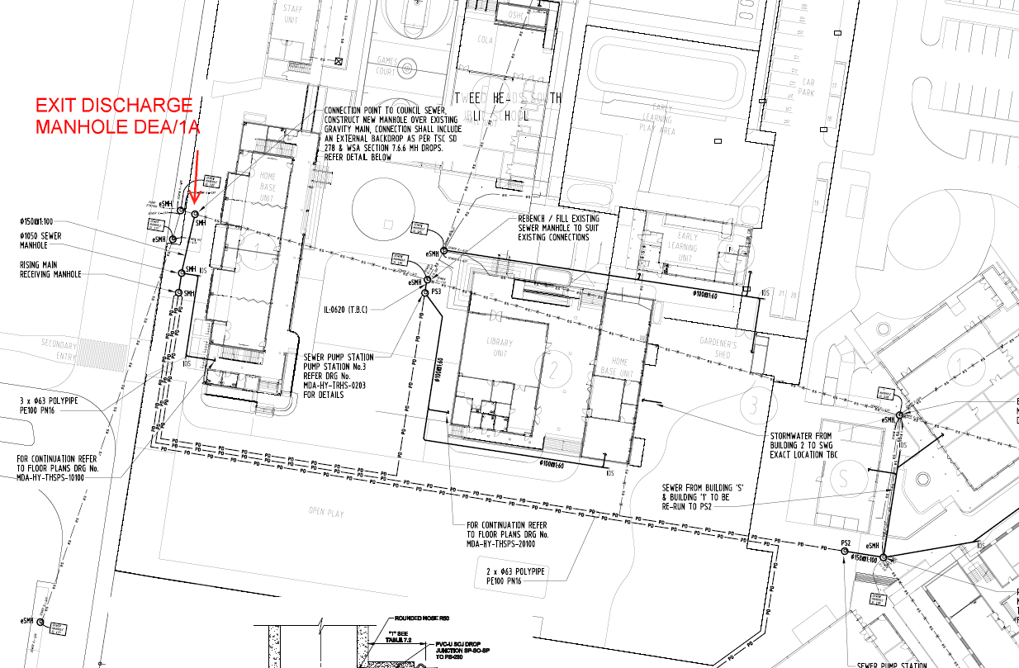
Figure 10: Excerpt of s68 Approval – SSW21/0006
To ensure consistency between the subject application and current Section 68 Application the following condition has been applied:

The proposed sewer diversion works shall be generally designed and constructed in accordance with the MDA Consulting Engineers - Hydraulic Services Plan - Drawing MDA-HY-TRHS-0201-RevC . Detailed design information shall be provided to council for the assessment of these sewer diversion works. A Sewer Management Plan shall be submitted to support this application in demonstrating that the existing level of sewer service is maintained during construction. The application shall be submitted on Council's standard Section 68 Application form accompanied by the required attachments and the prescribed fee. The sewer diversion works shall not commence until prior separate approval to do so has been granted by Council under Section 68 of the Local Government Act.

Flooding
The subject site is mapped as being within the 1 in a 100 year flood level, probable maximum flood level and as being in a low flow area. The site is mapped as having a 2.6m AHD flood level, therefore the minimum floor level required is 3.1m AHD.
Proposed Floor Levels:
Proposed Building 1 = RL 3.1m
Second Storey floor 1 = 6.54m
Proposed Building 2 = RL 3.1m

The ground floor level for Buildings 1 and 2 comply with the minimum freeboard requirement of 0.5m above design flood level (2.6mAHD). All other works are alterations to existing buildings, which creates no impact on flood immunity or flood storage. The second storey floor for proposed Building 1 is located above the PMF.

Notwithstanding the above, the Probable Maximum Flood (PMF) level within the Tweed Valley Flood Study 2009 Update flood maps is 5.7mAHD.

The Flood Assessment provided with this DA (prepared by Meinhart, reference 121876, dated November 2019 and supported by an updated letter by same and dated 25 February 2021) and applicant’s SEE confirms sufficient time for students and staff to evacuate the site in the event of a flood. And, in any event, there is a suitable flood refuge area located above the PMF level on site.

All other buildings with proposed alterations in the Development Application will maintain their current ground floor levels, therefore the works will have no adverse impact.
Other approvals onsite
In addition to the subject application, there are other works on the site that are being carried out under separate Development Applications and planning pathways:
- Tweed River High School – Development Application (DA21/0312) for alterations and additions to the school. NRPP determination.
- Tweed South Public School – Part 5 approval – Development without consent. A Review of Environmental Factors (REF) has been prepared for the construction of a library and COLA, alterations to the existing administration building, alterations to existing early learning home base building, alterations and additions to the existing hall and COLA to accommodate administration for out-of-school-hours (OOSH) care and demolition of buildings and structures.
- Tweed Heads South Public School – Part 5 approval Development without consent. A Review of Environmental Factors (REF) has been prepared for replacement of the existing roofs over Blocks A & B.
- Tweed River High School – Part 5 approval – Development Without Consent. A REF has been prepared for demolition works and alterations to existing facilities.
- Tweed River High School - development application (DA21/0014) alterations and additions to an existing educational facility including earthworks and the removal of five existing trees (est. cost of works $638,000.00). Determined by Council under delegated authority
- Tweed River High School – Exempt development works including sports fields.
- Infrastructure upgrades including:
- Section 68 approval for alterations to the main sewer pipe and installation of Sewer Pump Stations; and
- Section 138 Roads Act Approval for works in the roadway on Heffron Street.

The proposed development was lodged on 26 April 2021 and was advertised and notified to adjoining and nearby properties for a period of 14 days from Wednesday 19 May 2021 to Wednesday 2 June 2021. A single submission was received from the general public.

The application was referred to NSW Essential Energy, NSW Rural Fire Services, Transport for NSW and the Tweed Byron Local Aboriginal Land Council. Comments from these agencies are discussed in detail later in the report.

Whilst Council officers are responsible for the assessment of the proposed development, Schedule 7 of State & Regional Development SEPP 2011 requires that Crown development with a Capital Investment Value (CIV) over $5 million is considered to be of regional significance and must be reported to the Panel for determination. Accordingly, the NRPP is the determining authority for this application.

Site Diagram: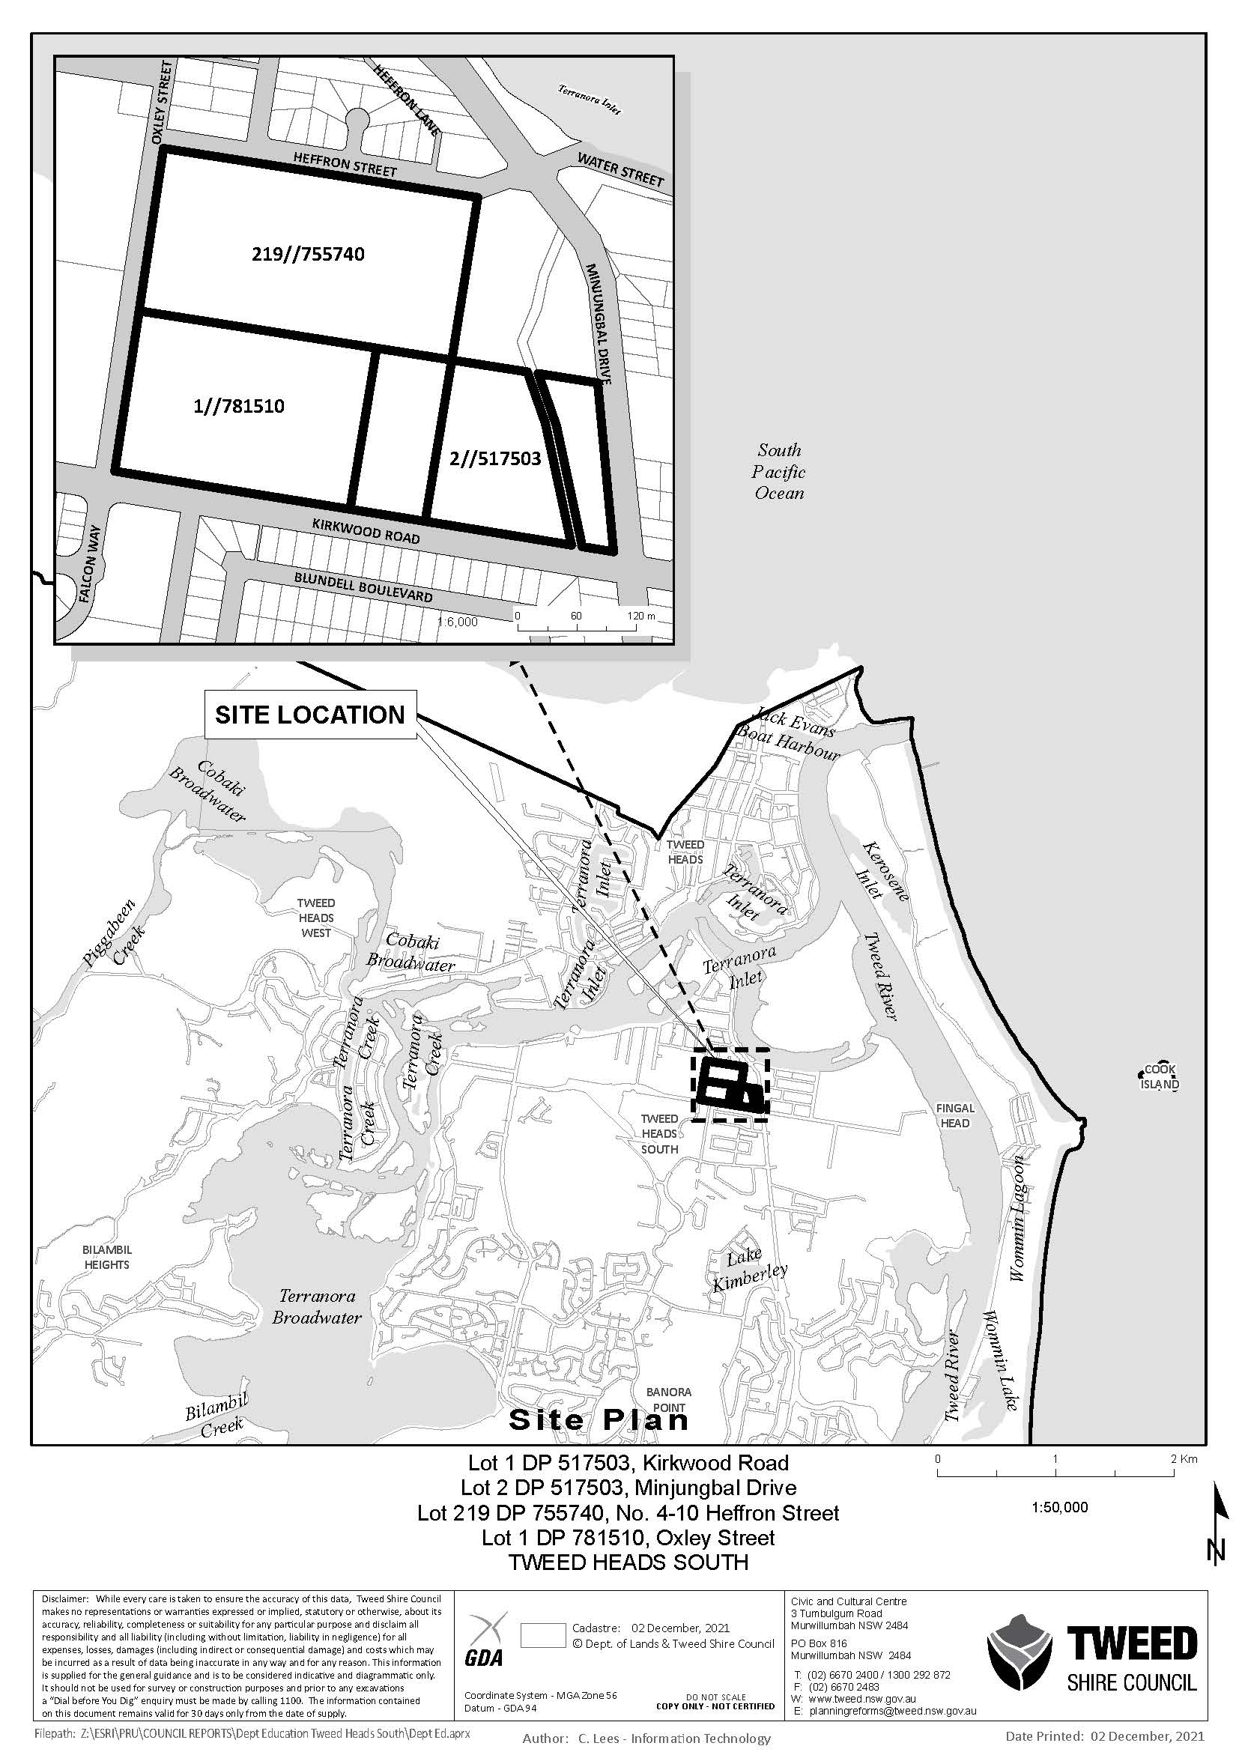 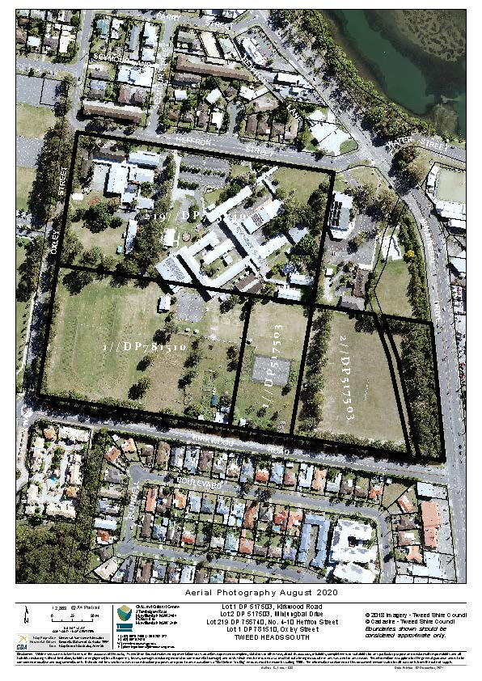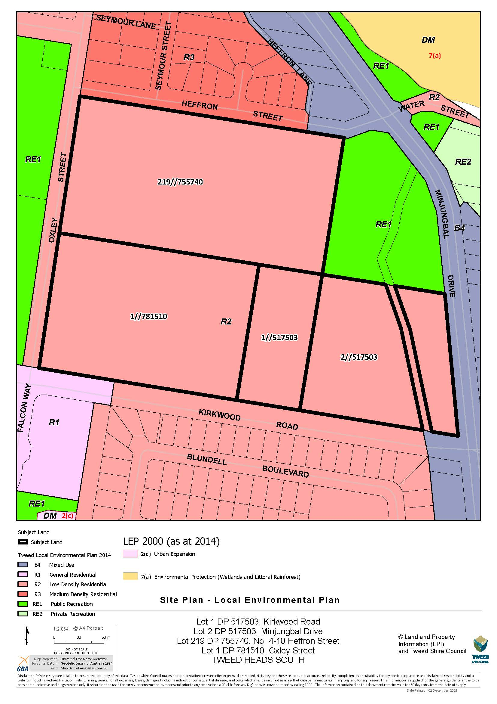
DEVELOPMENT/ELEVATION PLANS:
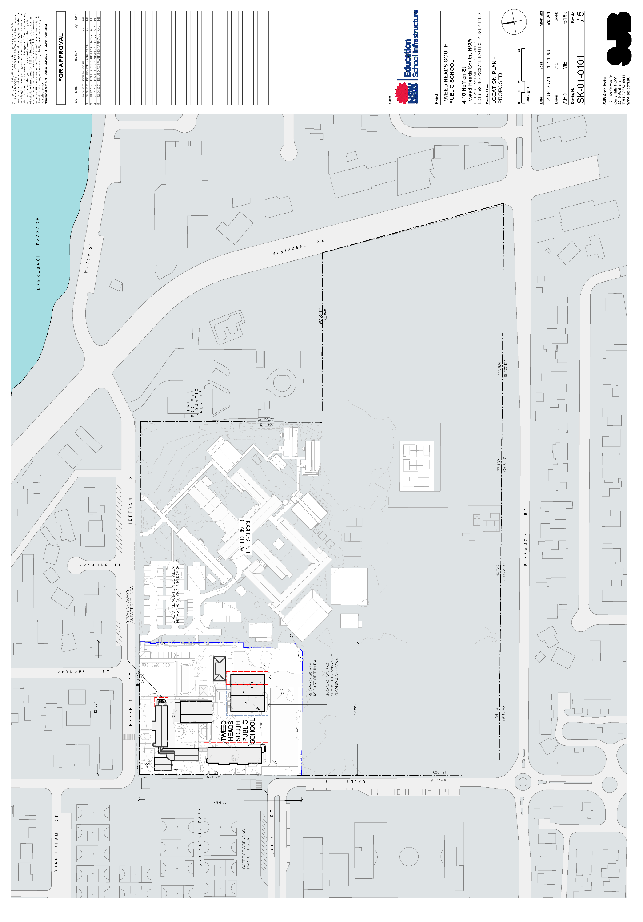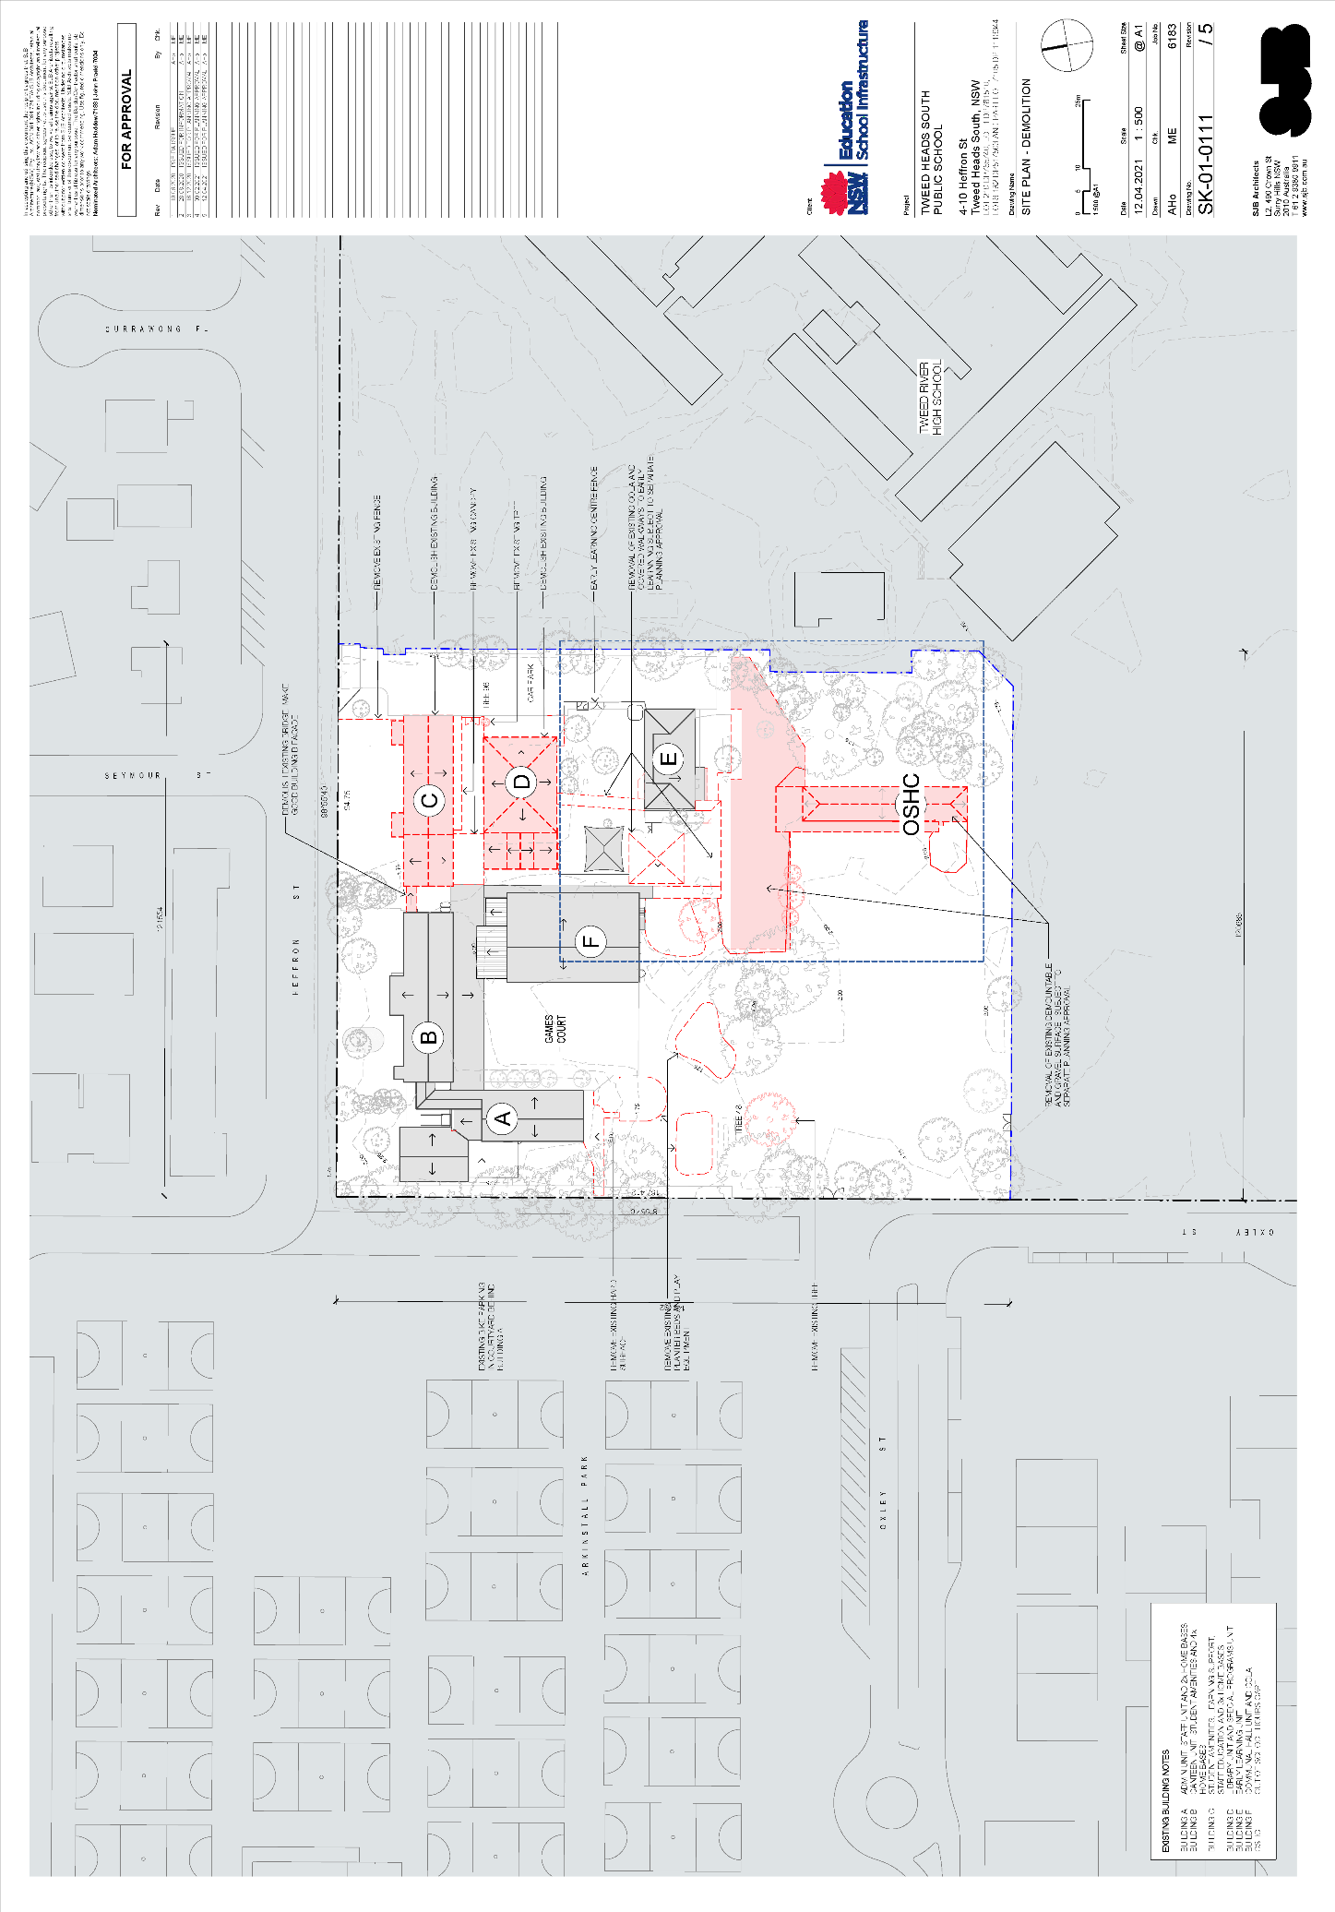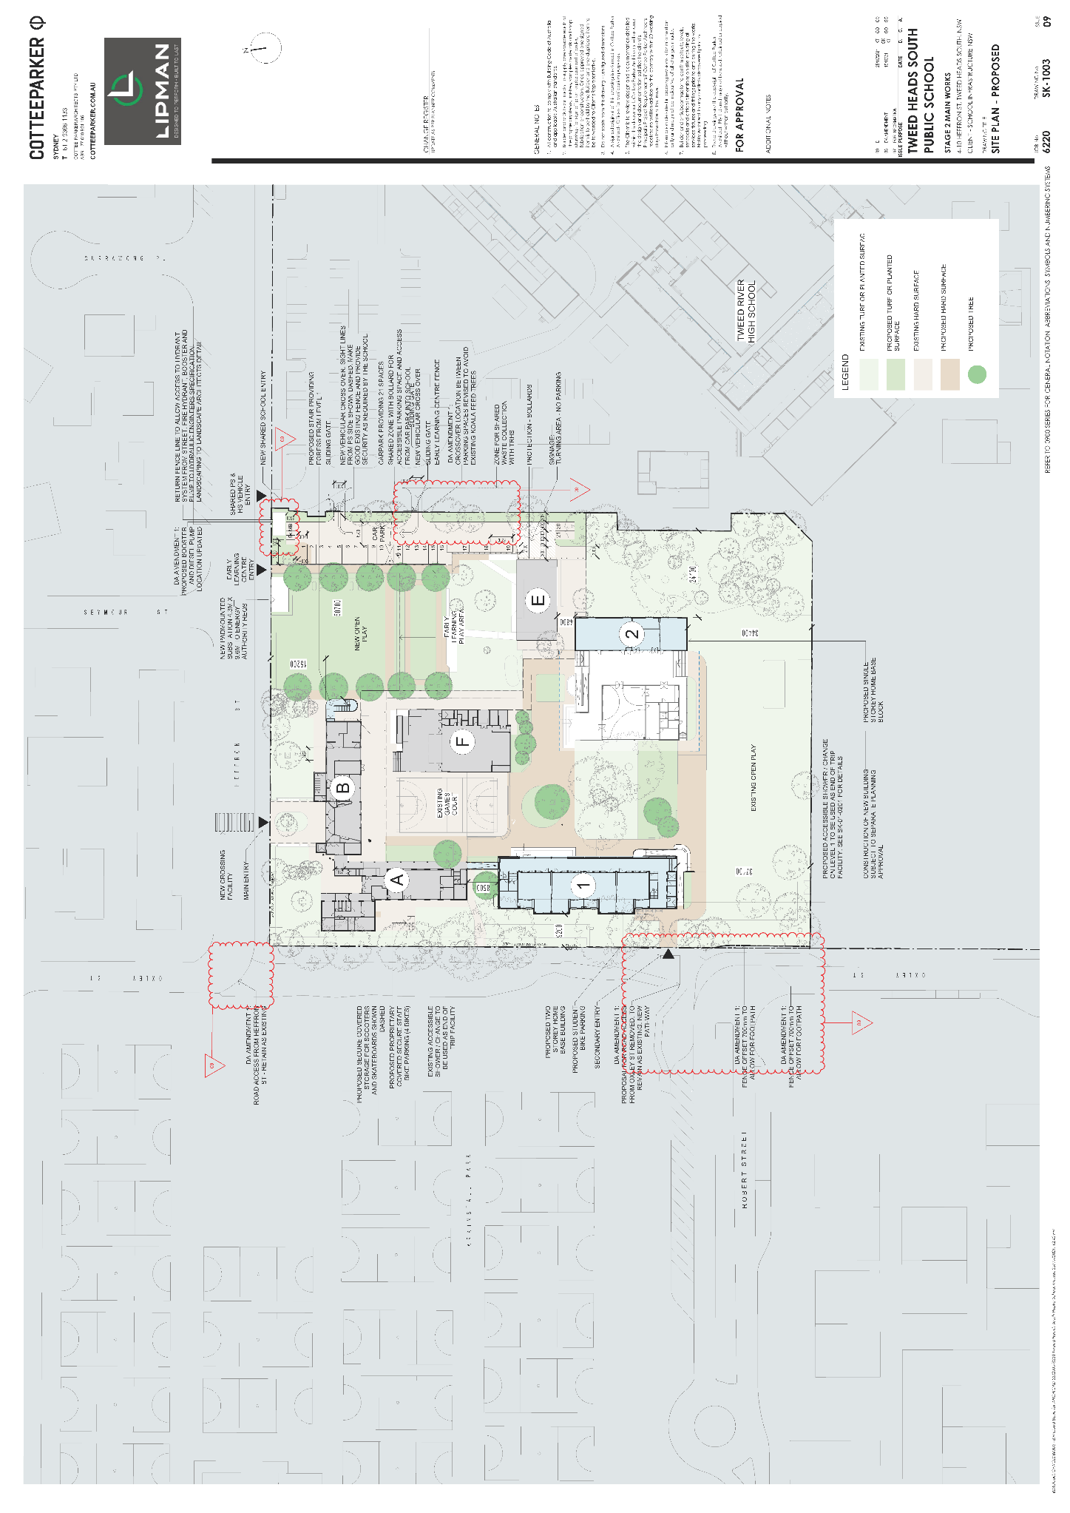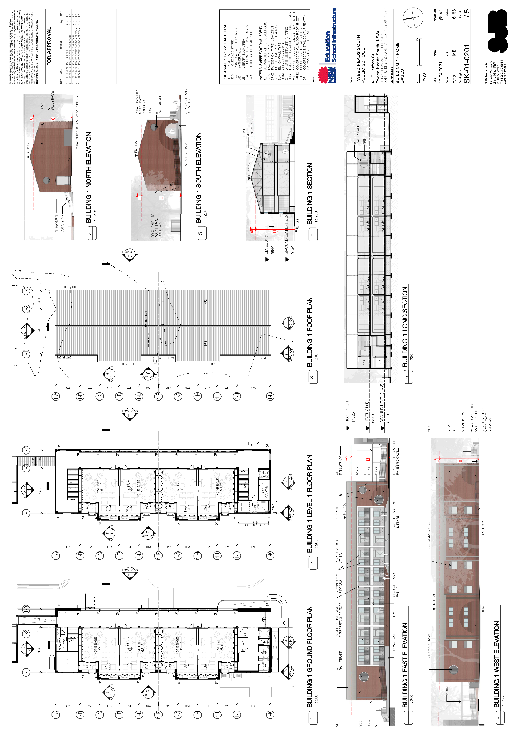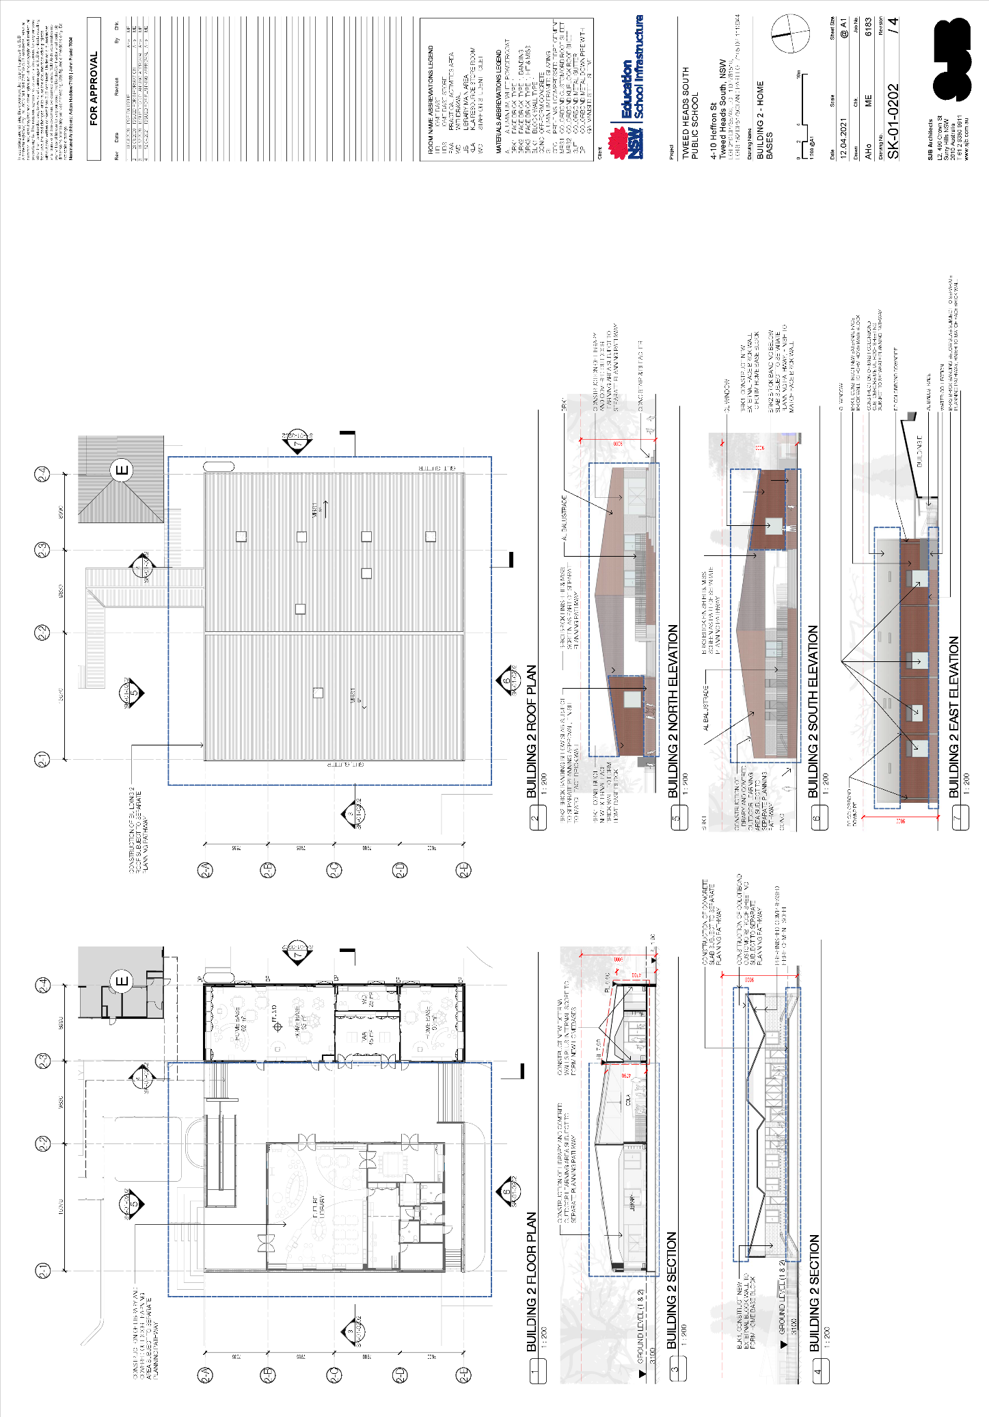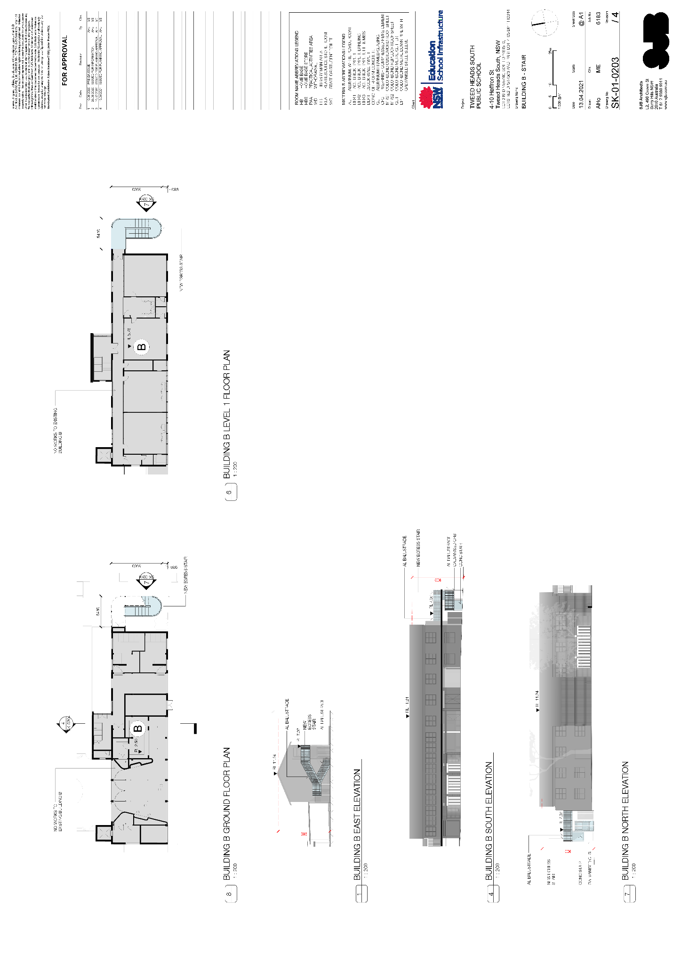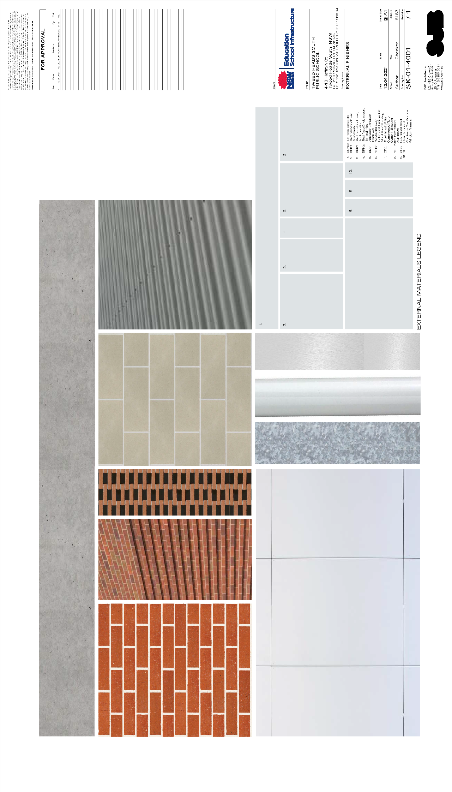
Considerations Under Section 4.15 Of The Environmental Planning And Assessment Act 1979:

(a) (i) The provisions of any environmental planning instrument

Tweed Local Environmental Plan 2014

Part 1 Preliminary
Clause 1.2 - Aims of the Plan

The aims of this plan as set out under Section 1.2 of this plan are as follows;
(1) This Plan aims to make local environmental planning provisions for land in Tweed in accordance with the relevant standard environmental planning instrument under section 33A of the Act.
(2) The particular aims of this Plan are as follows:
(a) to give effect to the desired outcomes, strategic principles, policies and actions contained in the Council’s adopted strategic planning documents, including, but not limited to, consistency with local indigenous cultural values, and the national and international significance of the Tweed Caldera,
(b) to encourage a sustainable, local economy, small business, employment, agriculture, affordable housing, recreational, arts, social, cultural, tourism and sustainable industry opportunities appropriate to Tweed Shire,
(c) to promote the responsible sustainable management and conservation of Tweed’s natural and environmentally sensitive areas and waterways, visual amenity and scenic routes, the built environment, and cultural heritage,
(d) to promote development that is consistent with the principles of ecologically sustainable development and to implement appropriate action on climate change,
(e) to promote building design which considers food security, water conservation, energy efficiency and waste reduction,
(f) to promote the sustainable use of natural resources and facilitate the transition from fossil fuels to renewable energy,
(g) to conserve or enhance the biological diversity, scenic quality, geological and ecological integrity of the Tweed,
(h) to promote the management and appropriate use of land that is contiguous to or interdependent on land declared a World Heritage site under the Convention Concerning the Protection of World Cultural and Natural Heritage, and to protect or enhance the environmental significance of that land,
(i) to conserve or enhance areas of defined high ecological value,
(j) to provide special protection and suitable habitat for the recovery of the Tweed coastal Koala.
The proposed development is considered to be generally in accordance with the aims of this plan having regard to its nature, permissibility at this location and subject to the recommended conditions of consent.
Clause 1.4 - Definitions
Under this Plan, the proposed development is considered to be an educational establishment, defined as follows:
educational establishment means a building or place used for education (including teaching), being:
(a) a school, or
(b) a tertiary institution, including a university or a TAFE establishment, that provides formal education and is constituted by or under an Act.

Part 2 Permitted or prohibited development
Clause 2.1 Land use Zones

The proposed development area is zoned as R2 Low Density Residential under the provisions of this plan.
Clause 2.3 – Zone objectives and Land use table

The objectives of the R2 zone are:

    - To provide for the housing needs of the community within a low density residential environment.
    - To enable other land uses that provide facilities or services to meet the day to day needs of residents.

The proposed development is considered to be consistent with the above objectives, by virtue of providing a service that meets the day to day need of residents. The subject application offers an opportunity to deliver a high quality educational establishment to service existing students and staff.

Part 4 Principal development standards
Clause 4.3– Height of Buildings

The objectives of this clause are as follows:

(a) to establish the maximum height for which a building can be designed,
(b) to ensure that building height relates to the land’s capability to provide and maintain an appropriate urban character and level of amenity,

(c) to ensure that taller development is located in more structured urbanised areas that are serviced by urban support facilities,
(d) to encourage greater population density in less car-dependant urban areas,
(e) to enable a transition in building heights between urban areas comprised of different characteristics,
(f) to limit the impact of the height of a building on the existing natural and built environment,
(g) to prevent gross overshadowing impacts on the natural and built environment.

The height of a building on any land is not to exceed the maximum height shown for the land on the Height of Buildings Map, which for the subject site is 9.0m from existing ground level. The proposed development has a maximum height of 10.146m. The proposal therefore seeks a clause 4.6 Variation to this clause.

The applicant has advised the following with this regard:

The proposed variation to the height standard is considered appropriate for the following reasons:
- The variation to the height control is a direct outcome of the site being located within the Tweed Valley Floodplain. This requires any new building to provide a minimum floor level of 2.6m AHD + 500mm freeboard so that it is above the 1 in 100 flood events. This results in the ground floor of the proposed Building 1 being elevated up to 1.29m above the existing ground level on site.

- The roof of the new two (2) storey building has shallow pitch of 16 degrees which responds to the other school buildings on site and roof pitch of surrounding residential dwellings to the north and south. To achieve compliance with the height control, the roof pitch would need to be lowered to less than 5 degrees and replaced with a single skillion roof. A skillion roof form is not consistent with the predominant school buildings that are being retained. A skillion roof is also a less sustainable option as natural ventilation and cooling of the building would be reduced due to the limited roof space between the ceiling and roof.

The variation is addressed further under the Clause 4.6 assessment of this report.

Clause 4.4 – Floor Space Ratio

TLEP 2014 provides for a Floor Space Ratio of 08:1 for the subject site. The subject site incorporates the existing Tweed Heads South Public School (subject to this application) and the existing Tweed River High School (subject to current DA, DA21/0312).

The proposed development has an FSR of 0.16:1. Accordingly, complies with the maximum FSR.

Clause 4.6- Exceptions to development standards

The objectives of this clause are as follows:

(a) to provide an appropriate degree of flexibility in applying certain development standards to particular development,
(b) to achieve better outcomes for and from development by allowing flexibility in particular circumstances.
Clause 4.6 advises that development consent may, subject to this clause, be granted for development even though the development would contravene a development standard imposed by this or any other environmental planning instrument.
In accordance with the provisions of Clause 4.6(3) development consent must not be granted for development that contravenes a development standard unless the consent authority has considered a written request from the applicant that seeks to justify the contravention of the development standard by demonstrating:
(a) that compliance with the development standard is unreasonable or unnecessary in the circumstances of the case, and

(b) that there are sufficient environmental planning grounds to justify contravening the development standard.
Clause 4.6 also advised that development consent must not be granted for development that contravenes a development standard unless:
(a) the consent authority is satisfied that:
(i) the applicant’s written request has adequately addressed the matters required to be demonstrated by subclause (3), and
(ii) the proposed development will be in the public interest because it is consistent with the objectives of the particular standard and the objectives for development within the zone in which the development is proposed to be carried out, and
(b) the concurrence of the Secretary has been obtained.
The subject application contravenes the mapped height limit of 9.0m under Clause 4.3 of the Tweed Local Environmental Plan 2014.
In accordance with this clause the applicant provided a written response to this clause (please refer to attachment 2 of this report).

Planning Officer Assessment:
In accordance with the provisions of Clause 4.6; consent must not be granted to the proposed height variation unless the following it is considered satisfied:

- that compliance with the development standard is unreasonable or unnecessary in the circumstances of the case, and
- that there are sufficient environmental planning grounds to justify contravening the development standard; and
- the proposed development will be in the public interest because it is consistent with the objectives of the particular standard and the objectives for development within the zone in which the development is proposed to be carried out.
The area is mapped as having a 9.0m height limit. Building 1 of the proposal has a total height of 10.146 metres figure below. The maximum variation sought is approximately 1.146m or 12.7%.
Figure 11: Extract from submitted plan depict height variation to building 1
The applicant has advised that compliance with the unreasonable in the circumstances as the proposed building height responds to the specific circumstances of the site, which in this case relate to the flooding affectation. This requires elevated floor levels, including a 500mm freeboard above the 1:100 year flood event. Council agrees that the site is mapped as flood prone land. The following section plan details the natural ground level and height of the ground floor level to comply with flood immunity. This is approximately 1.29m above NGL.

Figure 12: Section Plan detail floor heights (building 1)

Council agrees that the proposed roof form of building 1 has a shallow pitch of 16 degrees and responds to the other school buildings on site and roof pitch of surrounding residential dwellings to the north and south. To achieve compliance with the height control, the roof pitch would need to be lowered to less than 5 degrees and replaced with a single skillion roof.

As advised by the application a skillion roof form is not consistent with the predominant school buildings that are being retained.

The building is located behind Buildings A and B which face towards the primary entrance on Heffron Street. Building 1 is located on the western boundary adjacent unformed road reserve and the Tweed Heads Arkinstall Park Sports complex, minimal impact is anticipated and the height variation is not considered perceivable from outside the site.

It is also important to note that the proposed building 1 will also be screened by existing mature vegetation.

On this basis the development is considered to have minimal impact on the natural and built environment.

The development is not considered to obscure or negatively impact any significant view corridors, or overshadow any adjoining properties in relation to the original assessment comments.

The objectives of the R2 Low Density Residential zone are:
• To provide for the housing needs of the community within a medium density residential environment.
• To provide a variety of housing types within a medium density residential environment.
• To enable other land uses that provide facilities or services to meet the day to day needs of residents.

In this zone, the proposed development is permitted with consent and considered to be generally in accordance with the above objectives by way of providing for the housing needs of the community

Considering the above, the mapped 9.0m height limit is deemed to be unreasonable or unnecessary in the circumstances of this case. There are sufficient environmental planning grounds to justify the variation, and the development is considered to be in the interest of the public. Accordingly, the proposed exception to the 9.0m height limit (Clause 4.3, TLEP 2014) is supported at an officer level.

Part 5 Miscellaneous Provisions

Clause 5.10 – Heritage Conservation

The objectives of this clause are as follows:

(a) to conserve the environmental heritage of Tweed,
(b) to conserve the heritage significance of heritage items and heritage conservation areas, including associated fabric, settings and views,
(c) to conserve archaeological sites,
(d) to conserve Aboriginal objects and Aboriginal places of heritage significance.

The subject site is not mapped within a Heritage Conservation Area under this clause, nor is the site comprised of any Heritage Items.

The subject site does not contain any area of land mapped as predictive or known Aboriginal Cultural Heritage.

Notwithstanding the above, an item of Aboriginal significance had been identified on the adjoining site (TRHS) in mid-2020, when the site was subject to Aboriginal Heritage investigations initially as due diligence and to form the Aboriginal Cultural Heritage Assessment report for the redevelopment of the subject site.

On 19 November 2020 an application was made to the Secretary of Department of Premier and Cabinet for an Aboriginal Heritage Impact Permit (AHIP) pursuant to s.90 of the National Parks and Wildlife Act 1974. The application was to authorise test excavations necessary to determine the nature and extent of Aboriginal objects present within the school grounds of Tweed River High School and Tweed Heads South Public School. The information gathered from the proposed test excavations would then be used to inform the proposed redevelopment works for both schools.

Heritage NSW considered the application and supporting information and approved test excavations for the adjoining site.

In accordance with AHIP further works were undertaken.

The previously documented isolated Aboriginal object, 04-2-0254, could not be relocated as part of the recent site investigations. The final Aboriginal Cultural Heritage Assessment (ACHA) advised that “Given its surface location above 70 cm of modern overburden, it is unlikely within its primary context; and has likely been lost through natural soil processes. This site has been considered of low scientific significance”.

The final ACHA for the subject application and DA21/0312 advised:

Archaeological test excavations were undertaken across the study area, and focussing on areas of proposed ground disturbance. While earlier investigations predicted the potential for shell midden and/or deep cultural deposits, these works have revised this view. Specifically, the investigations have revealed substantive historical disturbance to depths of at least 70 cm below surface across the study area. Further, beneath this modern overburden – within which non-cultural shell material was found – there was evidence of inter-swale and/or swamp deposits and a high water table, which indicates that site was historically subject to regular water-logging and/or inundation. While these environments would have been attractive for exploitation in the past, occupation would more likely have occurred on drier ground outside of such swamp locales, and which was not evident within the study area during excavations. Overall, no cultural material was found in the upper 2 m of the soil profile during the excavations.

Chronological dating of the soil profile suggests the soil profile has been truncated by more recent activities, likely the development of the school in the 1960s/70s, and that much of the deposit dating to the last 5,000 years, within which the vast majority of cultural materials may be expected, has been lost.

Based on our understanding of the potential impacts for the project, it is considered that the majority of works are <2 m in depth and would have low risk of harming cultural materials. The isolated Aboriginal object is outside of any proposed works. At this stage, it cannot be robustly determined that any proposed activities, including piling, that exceeds 2 m below surface would have low or no impacts to cultural materials. While it is considered unlikely based on current evidence, it is recommended that such works are subject to monitoring by a heritage professional and/or Aboriginal stakeholder to ensure no inadvertent impacts occur.

Throughout the concurrent assessments of the subject application and DA21/0312 this matter was discussed with the NSW Office of Environment and Heritage who confirmed that as the ACHA report concluded that the development(s) for the school sites are low risk of harming cultural materials the AHIP was satisfied and further consultation was not required.

Further to the above the Tweed Byron Local Aboriginal Land Council were consulted and advised the following (consistent with DA21/0312):

TBLALC has worked closely with the various parties engaged on the Tweed River High School project…..I note that the Aboriginal object, 04-2-0254, has not been re-located (i.e.; now can’t be found on the site) and it is (was) outside the proposed impact areas. I also note that TBLALC agrees that there is a low risk of further Aboriginal objects being present within the study area. Therefore, TBLALC believes it will suffice to the condition the DA advising the applicant of their stop work responsibilities should any Aboriginal cultural object be revealed during the development works

TBLALC has reviewed the proposed application, DA21/0244 - alterations and additions to an existing educational establishment, including demolition and tree removal - Tweed River High School, against its Aboriginal cultural heritage mapping, cultural knowledge and the previous cultural advice provided to the applicant. TBLALC considers the application is consistent with the previous cultural advice and does not object to the application being determined.

The ACHA included on page ES2 a suite of recommendations which Council and The Tweed Byron Local Aboriginal Land Council are satisfied will ensure the protection of any potential Aboriginal Cultural Heritage. The following condition has been applied in this regard:

The development shall be completed in accordance with recommendations of the Aboriginal Cultural Heritage Assessment, Tweed Schools Redevelopment, prepared by Indigeco and dated June 2021.

Clause 5.11 – Bush fire hazard reduction

The subject site is mapped as bushfire prone land. Clause 5.11 advises that Bush fire hazard reduction work authorised by the Rural Fires Act 1997 may be carried out on any land without development consent.
The bushfire assessment was referred to NSW Rural Fire Service under Section 4.14 of the Environmental Planning and Assessment Act 1979. A response has been received which advises the following:
The New South Wales Rural Fire Service (NSW RFS) has reviewed the plans and documents received for the proposal and subsequently raise no concerns or issues in relation to bush fire.

No hazard reduction works are proposed or required. The application satisfies Clause 5.11 of the Tweed LEP 2014.

Clause 5.12 - Infrastructure development and use of existing buildings of the Crown

Clause 5.12 advises that this Plan does not restrict or prohibit, or enable the restriction or prohibition of, the carrying out of any development, by or on behalf of a public authority, that is permitted to be carried out with or without development consent, or that is exempt development, under State Environmental Planning Policy (Infrastructure) 2007.

Noted. The development is proposed to be carried out under State Environmental Planning Policy (Education and Childcare) 2017.

Clause 7.1 – Acid Sulfate Soils

The subject site is mapped as Class 2 Acid Sulfate Soils (ASS). The objective of this clause is to ensure that development does not disturb, expose or drain acid sulfate soils and cause environmental damage.
The application has been reviewed by Councils Environmental Health Unit, the following information was sought during the assessment process:

Please revise the Acid Sulfate Soil Management Plan included within the Detailed Site Investigation for Contamination for Tweed Heads South Public School, 4-10 Heffron Street, Tweed Heads prepared by Douglas Partners Pty Ltd dated 22 February 2021 (Project No. 97611.00; Document No. R.004.Rev2) that identifies an onsite location for available for treatment of acid sulfate soil where required and meets the requirements of the Waste Classification Guidelines – Part 4: Acid Sulfate Soils (NSW Environment Protection Authority, November 2014).

Acid sulfate soil investigations were identified in the revised Detailed Site Investigation for Contamination at Tweed Heads South Public School, 4-10 Heffron Street, Tweed Heads prepared by Douglas Partners Pty Ltd dated 20 August 2021 (Project 97611.00, R.004.Rev3).

This document includes an Acid Sulfate Soil Management Plan and identifies that onsite treatment is proposed within an area located in the south western section of the site (Drawing 2). Where offsite disposal is required, the material will be taken to landfill in accordance with the NSW EPA Waste Classification Guidelines – Part 4: Acid Sulfate Soils requirements.

The following condition has been applied in this regard:
All works for each Stage shall be carried out in accordance with the approved Acid Sulfate Soil Management Plan located in Section 13 of the Detailed Site Investigation for Contamination for Tweed Heads South Public School, 4-10 Heffron Street, Tweed Heads prepared by Douglas Partners Pty Ltd dated 20 August 2021 (Project 97611.00, R.004.Rev3) or to the satisfaction of Principal Certifier.

In this regard, the proposal is considered to be acceptable with respect to the acid sulfate soils on site and the provisions of this clause subject to the recommended condition of consent.

Clause 7.2 – Earthworks

The objective of this clause is to ensure that earthworks for which development consent is required will not have a detrimental impact on environmental functions and processes, neighbouring uses, cultural or heritage items or features of the surrounding land.
The proposed development includes only minor earthworks for footings/building works. Accordingly, minimal impact is expected. Appropriate conditions of consent relating to sediment and erosion control, to manage any impact has been applied and the proposal is considered to be in accordance with the provisions of clause 7.2.

Clause 7.3 – Flood planning

Repealed.

Clause 7.4 – Floodplain risk management

The site includes land that is between the flood planning level and the probable maximum flood level. Educational establishments are not specifically identified in this clause. Notwithstanding, the Flood Assessment provided with this DA confirms that should there be sufficient time for students and staff to evacuate the site in the event of a flood. And, in any event, there is a suitable flood refuge area located above the PMF level on site.

Clause 7.6 – Stormwater Management

The objective of this clause is to minimise the impacts of urban stormwater on land to which this clause applies and on adjoining properties, native bushland and receiving waters.

This clause outlines that consent must not be granted to development on land to which this clause applies unless the consent authority is satisfied that the development:

(a) is designed to maximise the use of water permeable surfaces on the land having regard to the soil characteristics affecting on-site infiltration of water, and
(b) includes, if practicable, on-site stormwater retention for use as an alternative supply to mains water, groundwater or river water, and
(c) avoids any significant adverse impacts of stormwater runoff on adjoining properties, native bushland and receiving waters, or if that impact cannot be reasonably avoided, minimises and mitigates the impact.

The legal point of discharge for the site is Heffron Street. A stormwater management report prepared by TTM has been lodged with the application. The plan advises an existing in ground private stormwater system currently conveys the school’s stormwater through to the public drainage system in Heffron Street. Heffron Street has a series of 825mm and 900mm diameter stormwater pipes which continue to Minjungbal Drive and discharge into the Terranora Inlet to the east.

The proposed re-development of the school includes 2 new buildings and a covered walkway. A number of buildings are also proposed to be demolished. No new car parking areas are proposed, with a re-configured entry provided for an existing car parking area with 21 vehicles.

The stormwater management plan proposes internal pit and pipe drainage to collect runoff from the new buildings and re-configured areas. No public infrastructure is proposed to be created.

On site detention (OSD) is proposed prior to discharge into the existing stormwater gully pit on Heffron Street. The volume of the tank is not detailed on the stormwater management plan, although is proposed to be approximately 1800mm high with a 900mm inlet pit. Further design detail of the OSD tank can be provided at the Section 68 stormwater application.

5000l ‘rainwater tanks’ are proposed for the two new buildings to assist with roof water on-site detention. A number of ‘storm sacks’ are also proposed for some internal stormwater inlet pits. The ‘storm sacks’ are high maintenance and will require regular cleaning out to avoid blockages in the private stormwater network for the school.

In terms of stormwater quality the submitted stormwater management plan has not proposed any stormwater quality measures for the school upgrade. It is noted that the upgrade generally consists of new roofs and a covered walkway. Stormwater quality measures are not required to treat roof water. It is noted that the car parking area is existing, therefore treatment will not be required for the existing car park.

A sediment / erosion control plan has been submitted with the application and is satisfactory

The proposal is considered to be acceptable with respect to the requirements of this clause.

Clause 7.7 – Drinking Water Catchments

Not applicable – the site is not located within a Drinking Water Catchment.

Clause 7.8 – Airspace operations

This clause provides for the effective and ongoing operation of the Gold Coast Airport by ensuring that such operation is not compromised by proposed development that penetrates the Limitation or Operations Surface for that airport and protects the community from undue risk from that operation.
Clause 7.8(3) states that the consent authority must be satisfied that the proposed development will not penetrate the Gold Coast Airport’s Obstacle Limitation Surface (OLS). The site is within the 49.5m Inner Horizontal OLS. The site has a natural ground level at the highest point of 2.0m. The development has a maximum height of 10.146m. Council officers consider that the provisions of Clause 6.9(3) have been met.

Clause 7.10 – Essential Services

This clause outlines that consent must not be granted to development unless the consent authority is satisfied that essential services such as water, electricity, sewerage, stormwater drainage and vehicular access are available or that adequate arrangements have been made to make them available when required.

The consent authority is satisfied that essential services such as water, electricity, sewerage, stormwater drainage and vehicular access are available or that adequate arrangements have been made to make them available when required.

Having regard to the above assessment, the subject application is considered to be generally in accordance with the provisions of the Tweed Local Environmental Plan 2014.
State Environmental Planning Policies

SEPP No. 55 - Remediation of Land

The objectives of SEPP No. 55 is to provide a State wide planning approach to the remediation of contaminated land and to require that remediation works meet certain standards and conditions.

SEPP No. 55 requires a consent authority to consider whether land is contaminated and if contaminated, that it would be satisfied that the land is suitable, in its contaminated state (or will be suitable after remediation). Further, it advises that if the land is contaminated and requires remediation, that the consent authority is satisfied that the land will be remediated before the land is used for that purpose. In particular it is noted that this SEPP states that a consent authority must not consent to the carrying out of any development on land unless:
(a) it has considered whether the land is contaminated, and
(b) if the land is contaminated, it is satisfied that the land is suitable in its contaminated state (or will be suitable, after remediation) for the purpose for which the development is proposed to be carried out, and
(c) if the land requires remediation to be made suitable for the purpose for which the development is proposed to be carried out, it is satisfied that the land will be remediated before the land is used for that purpose.
The subject application has been reviewed by Council’s Environmental Health Unit who have provided the following comment with respect to contamination associated with this proposal;

To address SEPP 55, a Detailed Site Investigation for Contamination for Tweed Heads South Public School, 4-10 Heffron Street, Tweed Heads prepared by Douglas Partners Pty Ltd dated 22 February 2021 (Project No. 97611.00; Document No. R.004.Rev2) has been submitted. Douglas Partners have confirmed:
- Total recoverable hydrocarbons (TRH) contamination was encountered in some surface soils, however the concentrations detected are not considered to present a significant health risk to the potential human or ecological receptors. The source of the TRH contamination in these locations has not been established.
- TRH and benzene, toluene, ethylbenzene and xylenes (BTEX) contamination was encountered in groundwater samples collected from all three on-site wells. The concentrations detected are not considered to present a significant health risk to the potential human or ecological receptors. The source of the TRH and BTEX contamination in groundwater is considered likely to be related to the nearby Coles Express service station (notified to NSW EPA as a contaminated site).
- Metal/metalloid contamination was encountered in groundwater that may present a risk to potential marine and freshwater ecosystems and will require treatment prior to off-site discharge.
- No buried waste products, ACM or hazardous building materials were identified during drilling.
- A waste classification assessment of the fill material indicates that it would be classified as General Solid Waste (non-putrescible) under NSW EPA Waste Classification Guidelines (EPA 2014).
- The site is compatible with the proposed continued scholastic development.

An unexpected finds procedure is noted within the report.

Council noted that the environmental consultant did not include the required Northern Rivers Contaminated Land Program - Contamination Report Summary Table and did not consider pre-demolition testing in relation to the buildings having brick and weatherboard construction with slab on ground. Further information was sought in this regard

In response:

A Contamination Report Summary Table prepared by Rob Muller of Douglas Partners dated 20 August 2021 was submitted.

A Pre-Demolition Testing Report for Tweed Heads South Public School, 10 Heffron Street, Tweed Heads South prepared by ENV Solutions Pty Ltd dated 16 September 2021 was been submitted to Council on 4 November 2021. Elevated concentrations of Aldrin and Dieldrin were noted in boreholes 5, 6 and 7 (all from Building D - Library) that exceeded HIL A in shallow soils 0-01.5m below ground level.

The library will be repurposed as an outdoor play area. As a result, a Detailed Site Investigation and Remediation Action Plan (Rev2) for Tweed Heads South Public School, 10 Heffron Street, Tweed Heads South prepared by ENV Solutions Pty Ltd dated 20 October 2021 (Job Number: 216191) has been submitted to delineate the lateral and vertical extent of soil contamination in this area and set out remedial requirements for the ongoing use as a school.

The contaminated material is limited to the shallow soils to 0.5m below ground level across the 280m2 footprint of the library building. A remedial action plan has been presented to remove this material and validate the area in accordance with NSW EPA statutory guidelines. ENV considers the site will be made suitable for the proposed school redevelopment and has included the Contaminated Report Summary Table

The following conditions have been applied:
All remediation and validation works associated with demolition of the library (Building D) are to be carried out in accordance with the Detailed Site Investigation and Remediation Action Plan (Rev2) for Tweed Heads South Public School, 10 Heffron Street, Tweed Heads South prepared by ENV Solutions Pty Ltd dated 20 October 2021 (Job Number: 216191) and NSW Environment Protection Authority contaminated land statutory guidelines. Any variation to the proposed remediation strategy shall be approved in writing by NSW EPA Site Auditor prior to the commencement of such work.
[GENNS01]
On completion of remediation and validation works and prior to commencement of construction works in the vicinity of the former library footprint, a Site Remediation and Validation Report, and where required Environmental Management Plan, prepared by a suitably qualified environmental consultant in accordance with NSW Environment Protection Authority contaminated land statutory guidelines shall be submitted to the Principal Certifier confirming that the site is suitable for the proposed use. The report must be accompanied by the Northern Rivers Contaminated Land Program - Contamination Report Summary Table available at <https://www.tweed.nsw.gov.au/ContaminatedLand>.

SEPP (State and Regional Development) 2011

This SEPP was gazetted on 1 October 2011 and nominates a range of developments for which the Minister or the local Council is the consent authority and the circumstances where the Joint Regional Planning Panel may have the role of determining an application, depending on the class of development (type of use and value).

The estimated cost of the proposed development is $11,376,993.00 which is above the $5 million threshold for Crown development as specified by the Environmental Planning & Assessment Act 1979.

Therefore in this case Tweed Shire Council is the consent authority for this Development Application but the NRPP will have the determining powers of the Consent Authority and will be responsible for determining the application

SEPP (Infrastructure) 2007

The aim of this Policy is to facilitate the effective delivery of infrastructure across the State by:

(a) improving regulatory certainty and efficiency through a consistent planning regime for infrastructure and the provision of services, and
(b) providing greater flexibility in the location of infrastructure and service facilities, and
(c) allowing for the efficient development, redevelopment or disposal of surplus government owned land, and
(d) identifying the environmental assessment category into which different types of infrastructure and services development fall (including identifying certain development of minimal environmental impact as exempt development), and
(e) identifying matters to be considered in the assessment of development adjacent to particular types of infrastructure development, and
(f) providing for consultation with relevant public authorities about certain development during the assessment process or prior to development commencing.

Clause 45 Determination of development applications—other development

This clause applies to a development application (or an application for modification of a consent) for development comprising or involving any of the following—
(a) the penetration of ground within 2m of an underground electricity power line or an electricity distribution pole or within 10m of any part of an electricity tower,
(b) development carried out—
(iii) within 5m of an exposed overhead electricity power line,
(c) installation of a swimming pool any part of which is—
(i) within 30m of a structure supporting an overhead electricity transmission line, measured horizontally from the top of the pool to the bottom of the structure at ground level, or
(ii) within 5m of an overhead electricity power line, measured vertically upwards from the top of the pool,
(d) development involving or requiring the placement of power lines underground, unless an agreement with respect to the placement underground of power lines is in force between the electricity supply authority and the council for the land concerned.
Clause 2 advises that before determining a development application (or an application for modification of a consent) for development to which this clause applies, the consent authority must:

(a) give written notice to the electricity supply authority for the area in which the development is to be carried out, inviting comments about potential safety risks, and
(b) take into consideration any response to the notice that is received within 21 days after the notice is given.

The application was referred to Essential Energy in accordance with this clause.

Essential Energy advised the following:

We refer to the above matter and to your correspondence via the NSW Planning Portal seeking comment from Essential Energy in relation to the proposed development.

Strictly based on the documents submitted, Essential Energy has no comments to make as to potential safety risks arising from the proposed development.

Essential Energy makes the following general comments:

- If the proposed development changes, there may be potential safety risks and it is recommended that Essential Energy is consulted for further comment.

- Any existing encumbrances in favour of Essential Energy (or its predecessors) noted on the title of the above property should be complied with.

- Prior to any demolition works commencing, any service line/s to the buildings to be demolished must be disconnected.

- The Applicant will need to engage the services of an Accredited Service Provider to ensure adequate provision of power is available to the new buildings in accordance with industry standards.

- In addition, Essential Energy’s records indicate there is electricity infrastructure located within the property and within close proximity of the property. Any activities within these locations must be undertaken in accordance with the latest industry guideline currently known as ISSC 20 Guideline for the Management of Activities within Electricity Easements and Close to Infrastructure. Approval may be required from Essential Energy should activities within the property encroach on the electricity infrastructure.

- Prior to carrying out any works, a “Dial Before You Dig” enquiry should be undertaken in accordance with the requirements of Part 5E (Protection of Underground Electricity Power Lines) of the Electricity Supply Act 1995 (NSW).

- Given there is electricity infrastructure in the area, it is the responsibility of the person/s completing any works around powerlines to understand their safety responsibilities. SafeWork NSW (www.safework.nsw.gov.au) has publications that provide guidance when working close to electricity infrastructure. These include the Code of Practice – Work near Overhead Power Lines and Code of Practice – Work Underground Assets.

Council has applied the following conditions in this regard:

Any existing encumbrances in favour of Essential Energy (or its predecessors) noted on the title of the above property should be complied with.
Prior to any demolition works commencing, any service line/s to the buildings to be demolished must be disconnected.
The Applicant will need to engage the services of an Accredited Service Provider to ensure adequate provision of power is available to the new buildings in accordance with industry standards.
Essential Energy’s records indicate there is electricity infrastructure located within the property and within close proximity of the property. Any activities within these locations must be undertaken in accordance with the latest industry guideline currently known as ISSC 20 Guideline for the Management of Activities within Electricity Easements and Close to Infrastructure. Approval may be required from Essential Energy should activities within the property encroach on the electricity infrastructure.
Prior to carrying out any works, a “Dial Before You Dig” enquiry should be undertaken in accordance with the requirements of Part 5E (Protection of Underground Electricity Power Lines) of the Electricity Supply Act 1995 (NSW).
Given there is electricity infrastructure in the area, it is the responsibility of the person/s completing any works around powerlines to understand their safety responsibilities. SafeWork NSW (www.safework.nsw.gov.au) has publications that provide guidance when working close to electricity infrastructure. These include the Code of Practice - Work near Overhead Power Lines and Code of Practice - Work Underground Assets.

Clause 45 is considered satisfied.

SEPP (Koala Habitat Protection) 2019

This SEPP aims to encourage the proper conservation and management of areas of natural vegetation that provide habitat for koalas to ensure a permanent free-living population and reverse the trend of koala population decline.

Pursuant to Clause 19, the Tweed Coast Comprehensive Koala Plan of Management (TCCKPoM) remains in force in the area that includes the site. The applicant provided a BDAR provided with this DA has conducted a Koala Habitat Assessment in accordance with the requirements of the TCCKPoM.

Assessment Comments:
With reference to the Tweed Coast Comprehensive Koala Plan of Management 2020, the site occurs within the Tweed Heads Koala Management Area. Preferred Koala Food Trees (Eucalyptus robusta) remain interspersed across the grounds of the school. No works subject to application require the removal of Koala food trees.

SEPP (Coastal Management) 2018

The subject site is mapped as being within the Coastal Environment Area and Coastal Use Area with the proposed development being located within these areas. The objectives of each clause are as follows:
13 Development on land within the coastal environment area
(1) Development consent must not be granted to development on land that is within the coastal environment area unless the consent authority has considered whether the proposed development is likely to cause an adverse impact on the following:
(a) the integrity and resilience of the biophysical, hydrological (surface and groundwater) and ecological environment,
(b) coastal environmental values and natural coastal processes,
(c) the water quality of the marine estate (within the meaning of the Marine Estate Management Act 2014), in particular, the cumulative impacts of the proposed development on any of the sensitive coastal lakes identified in Schedule 1,
(d) marine vegetation, native vegetation and fauna and their habitats, undeveloped headlands and rock platforms,
(e) existing public open space and safe access to and along the foreshore, beach, headland or rock platform for members of the public, including persons with a disability,
(f) Aboriginal cultural heritage, practices and places,
(g) the use of the surf zone.
(2) Development consent must not be granted to development on land to which this clause applies unless the consent authority is satisfied that:
(a) the development is designed, sited and will be managed to avoid an adverse impact referred to in subclause (1), or
(b) if that impact cannot be reasonably avoided—the development is designed, sited and will be managed to minimise that impact, or
(c) if that impact cannot be minimised—the development will be managed to mitigate that impact.
(3) This clause does not apply to land within the Foreshores and Waterways Area within the meaning of Sydney Regional Environmental Plan (Sydney Harbour Catchment) 2005.
14 Development on land within the coastal use area
(1) Development consent must not be granted to development on land that is within the coastal use area unless the consent authority:
(a) has considered whether the proposed development is likely to cause an adverse impact on the following:
(i) existing, safe access to and along the foreshore, beach, headland or rock platform for members of the public, including persons with a disability,
(ii) overshadowing, wind funnelling and the loss of views from public places to foreshores,
(iii) the visual amenity and scenic qualities of the coast, including coastal headlands,
(iv) Aboriginal cultural heritage, practices and places,
(v) cultural and built environment heritage, and
(b) is satisfied that:
(i) the development is designed, sited and will be managed to avoid an adverse impact referred to in paragraph (a), or
(ii) if that impact cannot be reasonably avoided—the development is designed, sited and will be managed to minimise that impact, or
(iii) if that impact cannot be minimised—the development will be managed to mitigate that impact, and
(c) has taken into account the surrounding coastal and built environment, and the bulk, scale and size of the proposed development.
(2) This clause does not apply to land within the Foreshores and Waterways Area within the meaning of Sydney Regional Environmental Plan (Sydney Harbour Catchment) 2005
Clauses 13 and 14 states that consent must not be granted unless the consent authority is satisfied the proposed development will not significantly impact upon the coastal environmental and coastal use areas. The proposal is for the change of use of an existing building within an established commercial core, as such:
- The proposed development will not impact or increase the likelihood of coastal impacts;
- There will be no impact on water quality and the site is not within close proximity to coastal lakes;
- The site is significantly separated from any marine vegetation, headlands or rock platforms;
- The proposal will have no impact on open space or access to the foreshore
- The is mapped as a known location under the Tweed Aboriginal Cultural Heritage Management Plan, however works are outside of this area and the development has been supported by a ACHMA report.;
- The proposal will not overshadow the foreshore, nor impact on views to the foreshore from any public place;
- The proposal will not result in any adverse impacts on the visual amenity and scenic qualities of the foreshore;
Accordingly, Council officers are satisfied that the proposed development meets the provisions of clause 13 and 14 of the Coastal Management SEPP.

SEPP (Educational Establishments and Child Care Facilities) 2017

The aim of this Policy is to facilitate the effective delivery of educational establishments and early education and care facilities across the State by:

(a) improving regulatory certainty and efficiency through a consistent planning regime for educational establishments and early education and care facilities, and
(b) simplifying and standardising planning approval pathways for educational establishments and early education and care facilities (including identifying certain development of minimal environmental impact as exempt development), and
(c) establishing consistent State-wide assessment requirements and design considerations for educational establishments and early education and care facilities to improve the quality of infrastructure delivered and to minimise impacts on surrounding areas, and
(d) allowing for the efficient development, redevelopment or use of surplus government-owned land (including providing for consultation with communities regarding educational establishments in their local area), and
(e) providing for consultation with relevant public authorities about certain development during the assessment process or prior to development commencing, and
(f) aligning the NSW planning framework with the National Quality Framework that regulates early education and care services, and
(g) ensuring that proponents of new developments or modified premises meet the applicable requirements of the National Quality Framework for early education and care services, and of the corresponding regime for State regulated education and care services, as part of the planning approval and development process, and
(h) encouraging proponents of new developments or modified premises and consent authorities to facilitate the joint and shared use of the facilities of educational establishments with the community through appropriate design.

Of particular relevance is Part 4 Schools – Specific development controls

Clause 33 Definition of “prescribed zone”
The proposed development is located on a prescribed zone, being land zoned R2 Low Density Residential

Clause 34 Development for the purpose of student accommodation
Not applicable to the subject application

Clause 35 Schools—development permitted with consent
Noted – the proposed development is permitted with consent.

Of particular relevance to the subject application is clause 35(6) which advises the following.

Before determining a development application for development of a kind referred to in sub clause (1), (3) or (5), the consent authority must take into consideration:
(a) the design quality of the development when evaluated in accordance with the design quality principles set out in Schedule 4, and
(b) whether the development enables the use of school facilities (including recreational facilities) to be shared with the community.

The proposed development is considered to enable the use of school facilities (including recreational facilities) with the community.

The subject application is a development referred to under clause 35(1).

Schedule 4 Schools – design quality principles

Principle 1—context, built form and landscape
Criteria | Applicant’s response
Schools should be designed to respond to and enhance the positive qualities of their setting, landscape and heritage, including Aboriginal cultural heritage. The design and spatial organisation of buildings and the spaces between them should be informed by site conditions such as topography, orientation and climate. | Tweed River High School is located on Bundjalung Country. The ground is a flat coastal lowland surrounded by the estuaries of Terranora Creek, Terranora inlet and Ukerebagh Passage. Ukerebah Nature Reserve is close to the school and is of significance to the community, both in terms of natural and cultural heritage.  Tweeds Heads South Public School is located on a large site shared with Tweed River High School. The two schools form the centre of a cluster of public facilities with the Tweed Regional Aquatic Centre, Tweed Shire Community Services and Tweed Heads Skatepark to the east and Arkinstall Park with sports fields, tennis and netball courts to the west. This cluster is surrounded by a suburban neighbourhood of predominantly detached dwellings with a distinctly casual character. Adjacent the site is Minjungbal Drive, a regional road linking the Tweed Heads South to the Pacific Highway.  Tweed Heads South Public School was established in 1958. It was originally a single building school occupying Building C, a two storey weatherboard addressing Heffron Street. Additional buildings were added over time including Buildings A and B, two storey brick classroom blocks extending the street front to Heffron Street and Oxley Street. Building D, the library, and Building E, the early learning centre, were positioned in the centre of the site. Building H, the community hall, was constructed in the early 2000s as part of the Building Education Revolution (BER), Together with Buildings A and B, an internal courtyard frames an existing games court.  The school has been designed to respond to an enhance the positive qualities of the setting as follows:  - sensitively respond to the suburban context with similar massing to neighbouring residential buildings  - mimic the school’s existing setbacks, building heights, face brick facade, and roof forms  - extend the site’s pattern of classroom buildings  - addressing the street set behind mature trees  - replicate the existing courtyard to provide a setting for school and community gatherings  New landscaping enhances site amenity as follows:  - provide a new outdoor learning space characterised by a ‘learning tree’ to focus the internal courtyard with strong links to the new library  - provide plant life and features to celebrate indigenous heritage and culture
Landscape should be integrated into the design of school developments to enhance on-site amenity, contribute to the streetscape and mitigate negative impacts on neighbouring sites.

School buildings and their grounds on land that is identified in or under a local environmental plan as a scenic protection area should be designed to recognise and protect the special visual qualities and natural environment of the area, and located and designed to minimise the development’s visual impact on those qualities and that natural environment.

Principle 2—sustainable, efficient and durable
Good design combines positive environmental, social and economic outcomes. Schools and school buildings should be designed to minimise the consumption of energy, water and natural resources and reduce waste and encourage recycling. | The proposed design sees the following positive social benefits:  - new opportunities for community gatherings in the enhanced internal courtyard and new Building 2 COLA  - outdoor learning spaces add alternative learning environments to cater for a wider variety of individual learning needs  - landscape design celebrates indigenous heritage  - Buildings A and 1 have circulation spaces overlooking the central courtyard promoting good site surveillance and student visibility  - a conservative approach to safety with all balustrades 1300mm high installed in areas with more than a 400mm fall.  The proposed design promotes positive environmental outcomes through passive design principles to create buildings that are suited to the hot, humid and wet climate of far north NSW. These see:  - maximise retention and utilisation of existing school buildings and other assets, unless identified as not fit for purpose or prone to significant flood damage  - locate all new buildings approximately 1.5m above the natural ground level to address 1 in 100 year flood events  - simple pitched roofs which overhang external circulation areas providing protection and respite from the sun and heavy rainfall  - perimeter eaves gutters and downpipes to maximise rainwater collection and reuse on the site  - durable materials of concrete, face brickwork, steel and aluminium are selected for the new works to ensure longevity of use and minimise maintenance and replacement of elements over time  - material selection promotes building product that can be recycled or repurposed at demolition stages to reduce waste and contribute to a circular life cycle of materials  - · the design proposal employs the use of PV cells, rain water collection and maximising natural light and ventilation in all new buildings.
Schools should be designed to be durable, resilient and adaptable, enabling them to evolve over time to meet future requirements.

Principle 3—accessible and inclusive
School buildings and their grounds should provide good wayfinding and be welcoming, accessible and inclusive to people with differing needs and capabilities. | The proposed design provides improved way-finding and accessibility as follows:  - A new single outdoor space linking the school entry to all school buildings offering a learning environment that is highly legible, intuitive and simple to navigate.  - New covered walkways provide a continuous accessible covered link throughout the school connected to existing covered walkway networks.  - Use ramps as the preferred form of vertical transportation from playground areas to ground floor buildings positioned 1.5m above ground level to clear the 1 in 100 year flood level. Minimising reliance on lifts to ground floor areas lessens student’s dependence on teachers for lift operations and allows the community to use the school’s facilities outside of hours without assistance from the school.  - Integrate ramps with outdoor learning spaces adjacent to primary circulation paths designed to be elements of the architecture rather than legislated additions.  - Provide a new lift to proposed Building 1 with direct connections to the new walkway and enhancing existing accessible networks.  - The new COLA to Building 2, positioned between the library and new classroom block, creates a generous, active and welcoming external gathering space to support community functions.  - Improved wayfinding and signage which – where possible - reflects local indigenous heritage and language.  Openness and clarity of spaces in the new work contributes to an improved sense of ‘place’ and ‘belonging’ with visual and physical connectedness throughout helping to reinforce and strengthen the school’s defining characteristics of inclusion and care
Schools should actively seek opportunities for their facilities to be shared with the community and cater for activities outside of school hours.

Note. Wayfinding refers to information systems that guide people through a physical environment and enhance their understanding and experience of the space.

Principle 4—health and safety
Good school development optimises health, safety and security within its boundaries and the surrounding public domain, and balances this with the need to create a welcoming and accessible environment. | The proposed works to the school significantly improves security of students and staff as follows:  - Proposed Building 1 runs parallel to the Oxley St boundary forming a firm edge to the street.  - Upgrade the school’s secure line eliminating multiple entries in preference for a single new entry on Heffron Street and a drop-off and pick-up entry from Oxley Street.  - All school entries are closed during school hours with visitors entering the school via a sign-in point in the Administration Unit in Building A.  - Upgrade and extend the school and early learning centre’s palisade fencing to match existing.  The proposed works significantly improve safety throughout the school as follows:  - Locate new classroom and library spaces above the 1 in 100 year flood level.  - Improve site visual links via a single external courtyard.  - Locate new buildings between existing trees to Oxley Street boundary and the school playground to minimise the risk of falling branches in play areas.  - Create planted garden beds below existing trees to the centre of the site to maximise plant retention and reduce the risk of branches in play areas.  - Provide 1300mm high balustrades throughout the school to areas 400mm above the ground plane.  - Provide bull-nose corners to face brickwork to provide soft rounded surfaces to mitigate student harm.  - Promote shading and outdoor covered spaces throughout the school to minimise sun damage.  - Safety to Heffron Street will be significantly improved seeing the removal of a right hand turn from Oxley Street and a new pedestrian crossing at the school entry.  - Vehicular access to the site is reduced to a single entry cross over from Heffron Road shared with the adjacent Tweed River High School.  - Provide a new drop-off and pick-up entry from Oxley Street to promote reduced traffic to Heffron Street.  - Remove site parking to the early learning centre to eliminate younger children waiting in cars whilst older children are signed out by parents.  - The proposal meets the conservative safety measures outlined in SINSW’s Educational Facilities Standards and Guidelines (EFSG).
Principle 5 - amenity
Schools should provide pleasant and engaging spaces that are accessible for a wide range of educational, informal and community activities, while also considering the amenity of adjacent development and the local neighbourhood. | The proposed works improve the school’s amenity as  follows:  - New buildings are designed to provide natural daylighting and cross ventilation.  - Building services offer teacher control over air conditioning and natural ventilation in learning areas, promoting adaptable learning environments to suit need, season and optimise resources.  - External circulation and new outdoor learning areas provide shaded and sun protection, located to capture prevailing breezes on the site.  - Gathering and movement spaces around the site are configured so they are open-ended and provide outlook and views from the school to surrounding natural features and landmarks.  - Landscape connections are key to defining the site’s character, and where appropriate, promote an interface with indigenous cultural heritage and science.  - New buildings are intended to be modest background elements that provide the structure and enclosure for significant outdoor spaces between buildings.  - Plant selection is inspired by the region’s lush native flora and is used to create a stimulating educational atmosphere that excites students to learn.  - A comfortable internal environment is aided by the linear building form, the shallow footprint ideal for cross ventilation.  - The extent of glazing and external shading to the east and west facades balance the need for natural light with the risk of thermal exposure.  - Large verandah spaces on the eastern facade improve amenity by offering outdoor learning spaces adjacent classroom areas.  - Windows are placed to provide outlook to existing mature trees and landscape recognising the role connection to Country plays in student learning and well-being
Schools located near busy roads or near rail corridors should incorporate appropriate noise mitigation measures to ensure a high level of amenity for occupants.

Schools should include appropriate, efficient, stage and age appropriate indoor and outdoor learning and play spaces, access to sunlight, natural ventilation, outlook, visual and acoustic privacy, storage and service areas.

Principle 6—whole of life, flexible and adaptive
School design should consider future needs and take a whole-of-life-cycle approach underpinned by site wide strategic and spatial planning. Good design for schools should deliver high environmental performance, ease of adaptation and maximise multi-use facilities. | Siting of proposed buildings re-orientates the school to amplify an existing central courtyard whilst ensuring future growth was not compromised.  New building works are limited to a relatively tight footprint. The area around demolished buildings is to be made good with landscaping, leaving the site with an overall built footprint similar to the existing situation.  The southern end of the central courtyard is left open, allowing for future expansion whilst maintaining the key organisational principle of school buildings around a central courtyard.  All new buildings are developed around the principle of ‘long life, loose fit’. A robust masonry skin protects a flexible interior set out according to the SINSW DfMA structural grid. Spaces are all rectilinear in shape and fixed services grouped together to ensure that interiors can be easily reconfigured in the future.  Internal learning spaces are generally clustered together with operable walls allowing spaces to be adapted and reconfigured to suit the school’s ambitions to adopt future focussed learning. Spaces can be used in various ways to suit different teaching configurations.
Principle 7—aesthetics
School buildings and their landscape setting should be aesthetically pleasing by achieving a built form that has good proportions and a balanced composition of elements. Schools should respond to positive elements from the site and surrounding neighbourhood and have a positive impact on the quality and character of a neighbourhood. | The existing buildings on site establish a good foundation for a nurturing and inviting school. The site is a collection of 1 and 2 storey red brick volumes which are reflective of the surrounding suburban context.  The proposed works are informed by the existing conditions. The proposed Building 1 is a linear two storey red brick building which extends from the existing Building A. The vertical expression of the Building A colonnade is continued in Building 1 where small setbacks from column, to slab edge, to fascia create a hierarchy of elements and establish a rhythm along the facade. Simple gutter detailing and expressive circular openings distinguish the building as a contemporary reinterpretation of a traditional classroom building. Delicate white metal balustrading contrasts the weight of the masonry and gives a sense of freshness and lightness.  The existing school is bought to life by a rich assortment of painted murals. Playful graphic brickwork on new building façades creates a dialogue with these murals and invites opportunities for new artwork.  The master plan is underpinned by a rich landscape experience activating spatial sequence with a variety of external spaces that provide incidental rest, opportunities for learning in landscape, a landscape palette drawn from the local environment and diversity of external space for play.
The built form should respond to the existing or desired future context, particularly, positive elements from the site and surrounding neighbourhood, and have a positive impact on the quality and sense of identity of the neighbourhood.

Clause 35(9) advises that a provision of a DCP that specifies a requirement in relation to school development permitted with consent has no effect, regardless of when the DCP was made.

Clauses 36 – 42 of Part 4 have been noted. The application does not require assessment against these clauses.

57 Traffic-generating Development
This clause applies to development for the purpose of an educational establishment—

(a) that will result in the educational establishment being able to accommodate 50 or more additional students, and
(b) that involves—
(i) an enlargement or extension of existing premises, or
(ii) new premises,
on a site that has direct vehicular or pedestrian access to any road.

Clause 2 advises that before determining a development application for development to which this clause applies, the consent authority must—
(a) give written notice of the application to Transport for NSW (TfNSW) within 7 days after the application is made, and
(b) take into consideration the matters referred to in subclause (3).

The proposed development is expected to increase the traffic generation rates from the use. Accordingly, the application was referred under Clause 57 to Transport NSW, the following was advised:

TfNSW understands that the development has been referred under the ESEPP to construct 2 new classrooms; make amendments to pedestrian entrances, and to upgrade the kiss and drop facility. There is to be an increase in student & staff numbers (some 170 additional students and 7 additional staff) with this development proposal, and as such, the development is Traffic Generating Development under clause 57 of ESEPP.

TfNSW also provided some comments to assist Council with its assessment, namely support and notations in relation to the proposed development. TfNSW comments were considered by Council, namely the Traffic Engineering unit during their assessment of the application.

The proposed development is considered consistent with the provisions of the SEPP (Educational Establishments and Child Care Facilities) 2017.

(a) (ii) The Provisions of any Draft Environmental Planning Instruments

There are no draft EPI’s.

(a) (iii) Development Control Plan (DCP)

Tweed Development Control Plan

A2-Site Access and Parking Code

The subject application proposes to close off the existing vehicle entrance from Heffron Street and rely on the TRHS vehicular access. An internal through road from the TRHS side is proposed to connect to the THSPS staff car parking area.

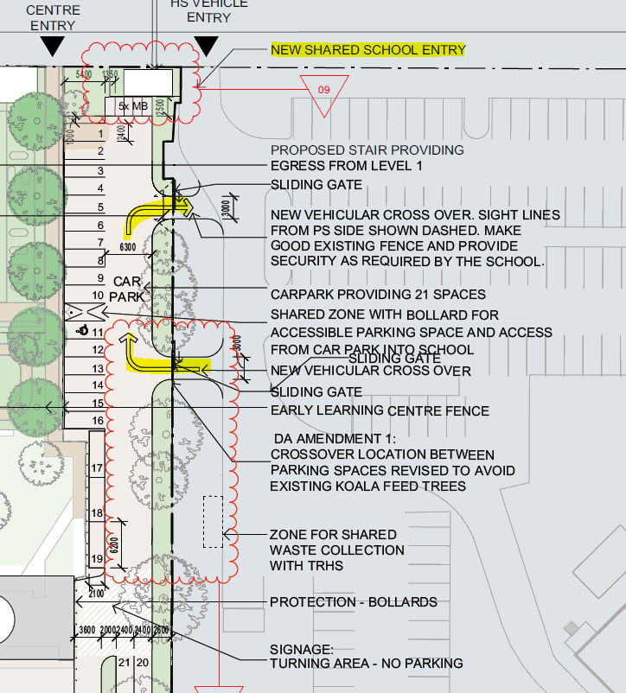
Figure 13: Proposed parking and access arrangement
The development seeks consent to provide an additional 7 onsite vehicle parking spaces which complies with the anticipated increase in staff numbers. The parking area will also be for staff only. Council supports these changes.

The Traffic assessment included an assessment of on-parking demand impacts associated with the development. It found that given the construction of active transport infrastructure, private vehicle demand is expected to decrease. Also, the parking impacts associated with the primary school are short-term and will typically last between 15 – 30 minutes during the AM and PM peak hours. The overall impact on surrounding residents and amenity is considered to be negligible.

The parking assessment is accepted.

Proposed changes to kiss’n’drop
The Heffron Street / Oxley Street intersection provides access to the current informal kiss’n’drop area. The current arrangements create a number of safety concerns.

The application as lodged sought consent to close off the Oxley Street/Heffron Street access, with a new access being installed on Oxley Drive/Robert Street for the kiss’n’drop and informal parking area, with a left-in/left-out driveway onto the Oxley Street (south)/Robert Street intersection.

Figure 14: Proposed Kiss'n'drop as lodged Source: Bitzios Traffic Report)
Council agreed that these changes should improve road safety and traffic flow and were supported in-principle. However, it became apparent that there was inadequate width to cater for two-way traffic in some sections without the need for widening and significant tree removal (Koala food trees).

In response to the above in consultation with Council the applicant’s amended the proposed kiss’n’drop to avoid excessive tree removal and triggering offset plantings. It is

The alternate kiss’n’drop arrangement maintains the same vehicle access operations under the original proposal, but proposes to position kiss’n’drop bays further south with vehicles accessing via Robert Street eastbound instead of Oxley Street via the initially proposed u-turn movement within the informal parking area.

The proposed location may result in the removal of a single tree. Council has ensure that were retention is unavoidable offset planting will be required under the Section 138 Application (see recommended condition below).

Figure 15: Proposed location of kiss’n’drop (source: Bitzios Traffic Engineering Plans)

The key components are:

- Vehicles will approach the Kiss’n’drop facility eastbound on Robert Street, which connects to Cunningham Street (to the north) and via Oxley Street south to extend to Kirkwood Road. The use of this ‘internal road’ section of Arkinstall Park removes vehicles from the school frontage on Heffron Street and includes roundabouts at either side of the Kiss’n’drop facility to allow vehicles to u-turn and re-circulate if required.
- 3.5m pavement widening and associated spoon drainage to accommodate a 2.5m Kiss’n’drop parking lane and 1.0m through-lane separation
- The Robert Street Kiss’n’drop facility provides 30m (five (5) vehicles) storage length as well as 36m (six (6) vehicles) of queueing length, before the existing angled parking spaces, for a total provision of 11 vehicles.
- Queuing for the Kiss’n’drop facility can accommodate for an additional 80m ( 13 vehicles) back to Robert Street’s internal roundabout adjacent to existing angled parking spaces. This potential queuing operation is consistent with the previous proposal which allowed Kiss’n’drop queuing behind parking spaces. This internal roundabout on Robert Street was designed for U-turn / circulation purposes only as part of the Arkinstall Park Sports Precinct design and does not incorporate any other side street approaches that would introduce a potential conflict point.
- The width of Robert Street pavement is 7.0m and allows sufficient width for a vehicle to pass Kiss’n’drop queueing if required. Attachment 2 demonstrates vehicle queuing as well as 600mm clearance between a queued vehicle and a passing vehicle ( if required). While the school is not proposing any increase in enrolments associated with the application, there is potential for the school in the future to increase up to 500 students.
- In regards to the capacity of the Kiss’n’drop to manage future increases in enrolments, the following is noted:
  - The proposed changes to the Kiss’n’drop operation for the school will be a significant improvement from the existing Kiss’n’drop facility which is a total of 36m in length and located directly adjacent to the bus zone. This facility does not incorporate any queuing capacity and requires vehicles to store along Heffron Street (westbound)
  - The proposal Kiss’n’drop facility and use of Robert Street provides significantly more queuing capacity than the current proposal as described above and also within a more controlled, lower speed road environment which includes speed treatment measures
- The location of the new school entry on the western side of the school is directly adjacent to largely under-utilised ( during pick-up periods) sports precinct parking area which gives parents and guardians a greater opportunity to “Park n Walk” to collect their children, reducing the demands for the Kiss’n’drop both now and as part of further potential enrolment increases at TSPS.

- Provision of a 2.0m wide footpath between the Kiss’n’drop bays and the revised site fence line. This path connects to the new school entry on the western side of the school and allows for students to be stored within school grounds and ‘called-up’ to access vehicles when required
- Provision of a 2.0m wide footpath extension connecting to existing footpath on Robert Street to the new school entry. This pathway further reduces the reliance on pick-up/drop-off demands along Heffron Street and allows enhanced separation of private pick-up/drop from school bus operations
- To accommodate the spatial requirements of the Kiss’n’drop facility and integrate with the existing road form on Oxley Street, the proposal will incorporate approximately 700mm encroachment into the school site. The proposal will realign the fence line to accommodate the Kiss’n’drop facility and include land dedication of Kiss’n’drop land to Council as road reserve

Figure 16: details showing kiss'n'drive allowing through traffic (source: Bitzios Traffic Engineering Plans)

The relocation of the Oxley Street kiss’n’drop access reduces potential for pedestrian and vehicle conflict, increases the safety of vehicle access for kiss/n/drive and also provides an opportunity to increase the length of the bus zone on the Heffron Street frontage, should additional capacity be required. The following works will require approval under a Section 138 application. The following conditions have been applied in this regard:

A Section 138 Roads Act application, with detailed engineering plans, is to be submitted to Council for approval for the following works external to the site:
a. Changes to the western pedestrian refuge in Heffron Street and associated signage and pavement markings
b. All works proposed within Oxley Street and Robert Street for the proposed kiss n drop zone

The application made under the Roads Act 1993 must also include the following:
a. Identification of all trees to be retained and protected within ten metres of the extent of works.
b. Details of tree management measures to be implemented during the construction phase in accordance with Australian Standard AS4970:2009 Protection of trees on development sites.
c. Where tree removal is deemed unavoidable and authorised by Council any tree removed shall be replaced at a ratio of 1:1 (remove to replace) with similar species of minimum 45 Litre stock size in accordance with Council’s Development Design Specification D14.08.03C Tree Planting and Location (for distances away from infrastructure such as light poles and driveways) and Standard Drawing Tree and Shrub Planting Details Dwg. No. SD701 (including the installation of root barrier) to the satisfaction of Councils General Manager or their delegate. Any replacement tree/s shall be installed prior to the operation of the development approved by this consent.
Approval of the Section 138 Application generally in accordance with the civil drawings prepared by ADG, dated 22 October 2021, Rev 1 is subject to the submission of details to the Council for referral to and consideration of the Local Traffic Committee for the proposed changes to the existing pedestrian refuge and all associated signage together with the proposed ‘kiss n drop’ (No Parking) zone.

A3-Development of Flood Liable Land

The subject site is indicated as being flood liable, being affected by both Councils Probable Maximum Flood (PMF) level and having a Q100 flood level of RL 2.6m AHD. Furthermore, the site is within a Low Flow Area. It is noted that the proposed development area is only located within the PMF area.

The application has been reviewed by Council’s Stormwater and Flooding Engineer with no objections raised to the proposed development as detailed elsewhere in this assessment.

It is noted that the proposal does not constitute habitable development. It is considered that the proposed development is generally in accordance with the provisions of DCP Section A3 and is acceptable in terms of development on flood liable land.

Tweed Community Engagement (formerly A11-Public Notification of Development Proposals)

The application was advertised and notified for a period of 14 days in accordance with this plan. During this a single submission was received.

A15 - Waste Minimisation and Management

Council's DCP Section A15 aims to minimise the generation of construction/demolition waste and facilitate effective ongoing waste management practices consistent with the principles of Ecologically Sustainable Development.
A Waste Management Plan (WMP) has been prepared by HMC Consulting. The WMP has considered the waste streams likely to be generated as a result of the demolition, construction and operational phases of the development.

The WMP has regard for the preservation of on site and public spaces, opportunities for reuse/recycling, transportation of waste, and appropriate storage, treatment and disposal of hazardous waste.

The application has been reviewed by Council’s Environmental Health Unit with respect to waste, with the following advice being provided ‘Some fill material will be required for the extension. General conditions to apply during construction works. The existing waste services for the school will (be) utilised during operation.’

As such, the proposal is considered to be acceptable having regard to waste management and the provisions of this section of the DCP.

A16 - Preservation of Trees or Vegetation

This section of the DCP aims to preserve and protect indigenous tree and vegetation species that contribute to the habitat and biodiversity of the area.
To facilitate the proposed development two (2) trees are identified to be removed as detailed in the Arboricultural Impact Assessment (AIA) – Tweed South Public School dated November 2020 prepared by Treescience. Of those 2 trees, one tree (Tree 48 – Harpulia pendula) is a local native species regarded as prescribed vegetation under Council’s Development Control Plan Section A16 Preservation of trees or vegetation.

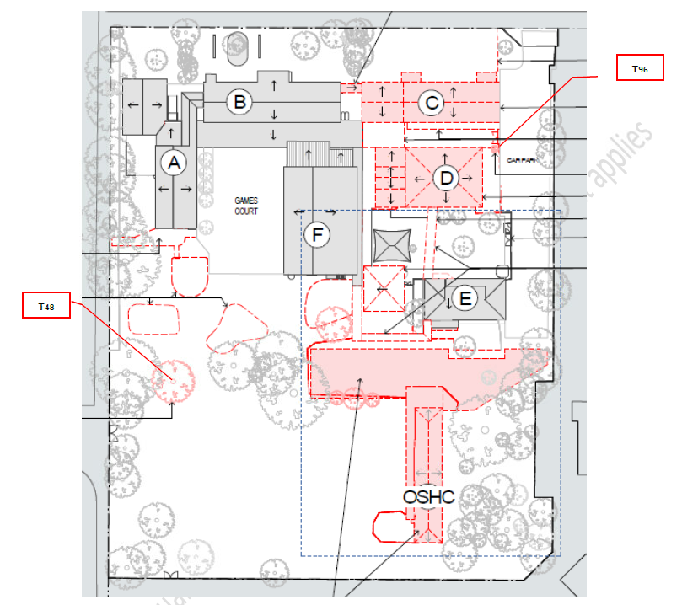
Figure 17: Trees to be removed
The following condition has been applied in this regard:

    - Vegetation removal shall be limited to two (2) trees identified in Section 04.2 of the Arboricultural Impact Assessment (AIA) – Tweed South Public School dated November 2020 prepared by Treescience. All other vegetation identified to be retained in the referenced AIA shall be afforded adequate protection and retained for the life of the development unless otherwise approved for removal by the relevant regulating authority.

B2-Tweed City Centre

2.0 City Centre Character Areas
The subject site is located within the Recreation and Public Use Precinct of B2.
The site provides for public education and does not impact on the ability for recreational use of the adjacent Arkinstall Park.

6.1 Energy Efficiency and Conservation
All non-residential development Classes 5-9 must comply with the Building Code of Australia energy efficiency provisions

The development has been supported by a BCA statement which confirms the proposed design is capable of satisfying the relevant provisions.

6.2 Water Conservation
Water saving measures are to be incorporated into non-residential building

Water tanks are provided on site to capture rainwater for reuse. Water fixtures in the new building will be rated to deliver water efficient flow.

6.3 Climate Change and Floodplain Management
Design flood levels for the city centre shall be consistent with the requirements of Section A3 – Development of Flood Liable Land in Tweed Shire Council’s Development Control Plan.

The proposed floor levels are above the design flood levels.

6.4 Reflectivity
New buildings and façades should not result in glare that causes discomfort or threatens safety of pedestrians or drivers.

Visible light reflectivity from building materials used on the façades of new buildings should not exceed 20%.

The proposed development will not result in glazing or reflective surfaces exceeding 20% of the building façade.

6.6 Waste and Recycling
All development must comply with Council’s building site waste management policy.
The waste management plan is to be prepared by a specialist waste consultant and is subject to approval by Council.

The development has been supported by a Waste Management. Appropriate conditions have been included.

(a)(iiia) Any planning agreement or any draft planning agreement under section 7.4

There are no planning or draft planning agreements applicable to the application.

(a) (iv) Any Matters Prescribed by the Regulations

Clause 92(a) Government Coastal Policy

The proposed development is located within the area covered by the Government Coastal Policy, and has been assessed with regard to the objectives of this policy. The Government Coastal Policy contains a strategic approach to help, amongst other goals, protect, rehabilitate and improve the natural environment covered by the Coastal Policy. It is not considered that the proposed development contradicts the objectives of the Government Coastal Policy, given its permissible nature on a site identified for development works.

Clause 92(b) Applications for demolition

The subject application includes the following minor demolition works:

  - Demolition of Building C (student staff and amenities, learning support, staff education facilities and four homebases);
  - Demolition of Building D (Library and special classroom facilities) and ancillary structures;
  - Demolition/removal of nominated hard surfaces, failing bitumen and gravel to the south of Building A and west of Building F;
  - Remove and relocate existing play equipment and raised planter beds;
  - Demolition of internal fence to the south of Building F;
  - Demolition of bridge connection between Building B and Building C and make good façade of Building B.

The application has been reviewed and conditions requiring compliance with Australian Standard AS 2601 "The Demolition of Structures" and to the relevant requirements of the WorkCover NSW, Work Health and Safety Regulation 2011 have been applied.

Clause 93 Fire Safety Considerations

Not applicable – the subject application is not for a change of use.

Clause 94 Buildings to be upgraded

The proposal includes alterations and additions to existing school buildings.

Under the requirements of Clause 94 of the Environmental Planning and Assessment Act 1979. The proposal will satisfy this clause as all works are to comply with the BCA. A Building Code of Australia 2019 Amendment 1 (BCA) Capability Statement has been submitted with the proposal prepared Group DLA.

(a) (v) Any coastal zone management plan (within the meaning of the Coastal Protection Act 1979)

Tweed Shire Coastline Management Plan 2005

This Plan applies to the Shire’s 37 kilometre coastline and has a landward boundary that includes all lands likely to be impacted by coastline hazards plus relevant Crown lands. The primary objectives of the Coastal Management Plan are to protect development; to secure persons and property; and to provide, maintain and replace infrastructure.
The proposed development is not considered to impact upon that coastline with regard to demands and issues identified within the Plan for the whole of the Tweed coastline (Clause 2.4.1) including: recreation; water quality; heritage; land use and development potential; coastal ecology and, social and economic demand. Under this plan, the subject site is not identified as having any key management actions or specific management strategies. The proposal is considered to be consistent with the objectives of the Management Plan.

The proposed development is not considered to impact upon that coastline with regard to demands and issues identified within the Plan for the whole of the Tweed coastline.

Tweed Coast Estuaries Management Plan 2004

This Plan applies to the Cudgen Creek and Cudgen Lake, Cudgera Creek and Mooball Creek systems and does not apply to the subject site.

Coastal zone Management Plan for Cobaki and Terranora Broadwater (adopted by Council at the 15 February 2011 meeting)

This Plan applies to the Cobaki and Terranora Broadwater and does not apply to the subject site

(b) The likely impacts of the development and the environmental impacts on both the natural and built environments and social and economic impacts in the locality

Context and Setting

The proposed development is considered to be acceptable, having regard to the established context and setting of the site, on which there is an already established school in operation.

The development will see an incremental increase in student and staff numbers.

The subject application offers an opportunity to deliver a high quality educational establishment to service existing students and staff.

Accordingly, there are no detrimental impacts envisaged as in relation to the subject application.

Amenity

During construction:

A Preliminary Construction Management Plan for Tweed Heads South Public School – 10 Heffron Street, Tweed Heads prepared by MMB Group Pty Ltd dated February 2021 was submitted to Council with the subject application. As per Section 4, an Environmental Management Plan (EMP) will be prepared prior to commencing works on site. This will include noise and vibration management, air quality and dust, and waste management.

The following condition in this regard has been applied:

Prior to the commencement of demolition and construction works, the Applicant must prepare an Environmental Management Plan (EMP) to the satisfaction of the Principal Certifier. The Plan shall include but is not limited to details of:
• hours of work;
• 24-hour contact details of site manager;
• dilapidation survey;
• removal of hazardous materials;
• sediment and erosion control;
• management of dust and odour to protect the amenity of the neighbourhood;
• acid sulfate soil and dewatering management;
• external lighting in compliance with AS 4282-1997;
• community consultation and complaints handling;
• noise and vibration management;
• waste classification procedure; and
• contaminated land unexpected finds procedure.
The Applicant must submit a copy of the Plan to the Principal Certifier and Council prior to commencement of work.
Noise and Vibration (operation):
An Event Schedule for THSPS has been provided. This details weekly, monthly and annual activities and events held at the school. This includes activities associated with the operation of the school as well as community events. The majority of events are held indoors to minimise potential emission and impacts on surrounding residential uses. Outdoor activities are held during the day period.
The site activities are unlikely to generate amenity impacts on neighbouring sites. The following (use) conditions have been applied:
The LAeq, 15 min noise level emitted from the premises shall not exceed the background noise level (LA90) by more than 5dB between 7.00am and 10.00pm, at the boundary of any affected residence. Notwithstanding the above, noise from the premises shall not be audible within any habitable room in any residential premises between the hours of 10.00pm and 7.00am weekdays and 10.00pm and 8.00am weekends.

Where practicable all air conditioning units and other mechanical plant or equipment are to be located so that any adverse noise impact due to their operation which may be or is likely to be experienced by any neighbouring premises is minimised. Where complaints are received and established by Council as genuine and in exceedance of the criteria in condition 90, air conditioning units and other mechanical plant or equipment shall be acoustically treated or shielded in accordance with the recommendations of a suitably qualified acoustic consultant, such that the operation of any air conditioning unit, mechanical plant or equipment does not result in the emission of offensive or intrusive noise

LPG tank:

Correspondence from Donnelley Simpson Cleary Consulting Engineers Pty Ltd dated 13 August 2021 (Job No: 8147) confirms the design and location of the proposed LPG bulk storage tank is in accordance with AS1596, AS2419.1, AS3000, and NSW WorkCover Storage and Handling of Dangerous Goods Code of Practice 2005. The following condition has been recommended:

The Liquefied Petroleum Gas (LPG) bulk storage tanks shall be installed and managed in accordance with AS1596:2014 - The storage and handling of LP Gas and the requirements of SafeWork NSW.
Flora and Fauna

Please consider:

- Biodiversity Conservation Act
- Local Land Services Amendment Act
- SEPP (Vegetation in Non-Rural Areas) 2017
- Land Management (Native Vegetation) Code 2017
- Biodiversity Values Map
- Sensitive Regulated Land Map
- Native Vegetation Map
- Tweed Shire Council Bushland Layer
- Endangered Ecological Communities
- Endangered Fauna
- Tweed Coast Koala Comprehensive Plan of Management

The proposed development Does satisfy Section 1.7 of the EP&A Act 1979 - Application of Part 7 of Biodiversity Conservation Act 2016 and Part 7A of Fisheries Management Act 1994.

Ecological values | - No remnant units of vegetation are mapped on site under the Tweed Vegetation Management Strategy 2004 (2009 Update).  - The Flora & Fauna Assessment Report (F&FAR) – Tweed Heads South Public School dated 12 March 2021 prepared by Kleinfelder, identifies 3 homogenous units of vegetation analogous with a Swamp Mahogany Swamp Forest on Coastal Lowlands vegetation type (See Figure 6). Based on site inspection the understory and mid-story of those mapped units has been highly modified, primarily comprising maintained turf grass and built up garden beds of mixed species.  - Two (2) threatened fauna species were detected during recent field survey and locations identified (Refer to Figure 7) in the Biodiversity Development Assessment Report prepared for the adjacent concurrent Tweed River High School upgrades (DA21/0312):  - Bush Stone-curlew (Burhinus grallarius) - heard south-east of the development footprint).  - Little Bent-winged Bat (Miniopterus australis) – identified on the adjacent TRHS  - The site occurs within the Tweed Heads Koala Management Area (Tweed Coast Comprehensive Koala Plan of Management 2020) . Preferred Koala Food Trees (Eucalyptus robusta) remain interspersed across the grounds of the school site  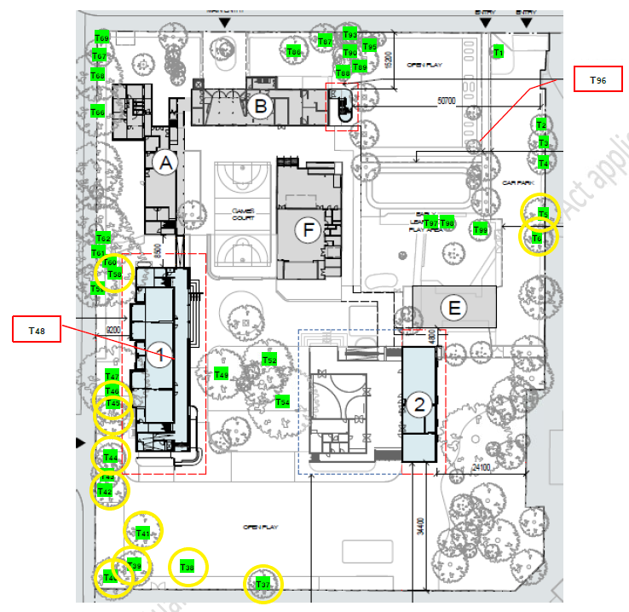  Extract from the AIA – Preferred Koala Food Trees highlighted in yellow

Council initially raised concerns in relation to the following
- Impact on mature trees within:
- the adjacent Oxley Street road reserve identified as a Kiss ‘n’ Drop car-parking facility
- the north-eastern carpark adjacent to access connecting to the Tweed River High School
- along the alignment of Oxley Street pedestrian access
- Management of Bush Stone-curlew during the construction phase.
- Construction access and set-down area – impact upon native trees.
- Inappropriate species nominated within the submitted Landscape Plan.

A comprehensive request for further information was sought from the applicant in relation to the above. In relation to the responses provided Council raise no objection to the proposal and are satisfied that the development would avoid adverse ecological impact subject to imposition of recommended biodiversity planning conditions to achieve the following:
- Clearly identify trees to be removed and trees to be retained and protected.
- Avoid unnecessary impact upon existing mature trees onsite through more refined civil infrastructure installation methodology under the advice of a consulting arborist.
- Appropriate management of Bush Stone-curlew during the construction phase through implementation of management actions in accordance with an endorsed plan.
- Preparation of a detailed landscape plan to clearly reflect 80% local native species plant selection.

Ground Water and Dewatering
The site is identified as having High groundwater vulnerability. Section 5.2.1 of the SEE advises “the excavation works to accommodate the footings associated with these buildings will extend 600-700mm below existing ground levels, and thus are highly unlikely to encounter groundwater”. Further, “in the unlikely event the dewatering is required, the dewatering management plan provides two options for disposal of the water. One, the water produced should be temporarily stored on site in holding tanks to allow monitoring of groundwater quality and treatment (as needed) to occur prior to discharge into the local stormwater drainage system with THCC approval. Alternatively, depending on the area available on site, the dewatering effluent could be returned to the ground via a trench, and without treatment. The preferred approach is the first option, being water temporarily stored on site in holding tanks to allow monitoring of groundwater quality and treatment (as needed) to occur prior to discharge”.

The site is generally low lying and groundwater levels can fluctuate. The applicant provided a Groundwater Investigation and Dewatering Management Plan for Tweed Heads South Public School, 4-10 Heffron St, Tweed Heads prepared by Douglas Partners Pty Ltd dated 22 February 2021 (Project No. 97611.00; Document No. R.008.Rev2) in the event that dewatering is required.

The Dewatering Management Plan (DMP) did not meet Council’s standard for reporting on dewatering proposals. Further information was sought with this regard.

A revised Groundwater Investigation and Dewatering Management Plan for Tweed Heads South Public School prepared by Douglas Partners Pty Ltd dated 23 August 2021 (Project No. 97611.00, R.008.Rev3) and supplemental information from the project contractor Lipman dated 24 August 2021 has been submitted that has addressed the information requested above.
As minor excavation is required, offsite dewatering is not anticipated as the groundwater will be pumped back into the ground. However in the event that offsite dewatering is required, a dewatering management plan has been provided and the applicant will seek Council approval prior to discharge. Holding tanks/sediment pond will be provided.
The following conditions have been applied in this regard:

- All works shall be carried out in accordance with the Groundwater Investigation and Dewatering Management Plan for Tweed Heads South Public School prepared by Douglas Partners Pty Ltd dated 23 August 2021 (Project No. 97611.00, R.008.Rev3) or to the satisfaction of Principal Certifier.
- All pumps used for onsite dewatering operations are to be installed on the site in a location that will minimise any noise disturbance to neighbouring or adjacent premises and be acoustically shielded to the satisfaction of the Principal Certifier so as to prevent the emission of offensive noise as a result of their operation.
- All waters pumped from the site in the dewatering process are to be treated with an effective deodoriser to the satisfaction of the Principal Certifier to neutralise any offensive odours.
- The point of discharge for offsite dewatering shall be approved by Council’s General Manager or delegate prior to installation and shall include a water sampling outlet.
- Pumps used for dewatering operations are to be electrically operated. Diesel pumps are not to be used unless otherwise approved by the Principal Certifier.
- The Principal Certifier shall be advised within 24 Hours in the event of detection of any failure associated with the dewatering activity being carried out on the site.

(c) Suitability of the site for the development

Surrounding Landuses/Development

The proposed development is located within an established school site and is considered a suitable development for the site given its function would be consistent with the operation of the previously approved school on the site, albeit increasing the extent of the development. While the surrounding area included low density residential development, the proposal is not considered to result in an unacceptable impact on surrounding development by virtue of being located on appropriately zoned land and the mitigation measures proposed as outlined throughout this report. Accordingly the application has been recommended for conditional approval.

Topography

The site has a gradual grade of 2% from the eastern boundary to the western boundary.

The earthworks proposed for the development involves minor excavation, for preparation of the building works.

The topography of the site is capable of accommodating the proposed development with minimal works.

Stormwater
The legal point of discharge for the site is Heffron Street. A stormwater management report prepared by TTM has been lodged with the application. The plan advises an existing in ground private stormwater system currently conveys the school’s stormwater through to the public drainage system in Heffron Street. Heffron Street has a series of 825mm and 900mm diameter stormwater pipes which continue to Minjungbal Drive and discharge into the Terranora Inlet to the east.

The proposed re-development of the school includes 2 new buildings and a covered walkway. A number of buildings are also proposed to be demolished. No new car parking areas are proposed, with a re-configured entry provided for an existing car parking area with 21 vehicles.

The stormwater management plan proposes internal pit and pipe drainage to collect runoff from the new buildings and re-configured areas. No public infrastructure is proposed to be created.

On site detention (OSD) is proposed prior to discharge into the existing stormwater gully pit on Heffron Street. The volume of the tank is not detailed on the stormwater management plan, although is proposed to be approximately 1800mm high with a 900mm inlet pit. Further design detail of the OSD tank can be provided at the Section 68 stormwater application.

5000l ‘rainwater tanks’ are proposed for the two new buildings to assist with roof water on-site detention. A number of ‘storm sacks’ are also proposed for some internal stormwater inlet pits. The ‘storm sacks’ are high maintenance and will require regular cleaning out to avoid blockages in the private stormwater network for the school.

In terms of stormwater quality the submitted stormwater management plan has not proposed any stormwater quality measures for the school upgrade. It is noted that the upgrade generally consists of new roofs and a covered walkway. Stormwater quality measures are not required to treat roof water. It is noted that the car parking area is existing, therefore treatment will not be required for the existing car park.

A sediment / erosion control plan has been submitted with the application and is satisfactory

Flooding
The subject site is mapped as being within the 1 in a 100 year flood level, probable maximum flood level and as being in a low flow area. The site is mapped as having a 2.6m AHD flood level, therefore the minimum floor level required is 3.1m AHD.
Proposed Floor Levels:
Proposed Building 1 = RL 3.1m
Second Storey floor 1 = 6.54m
Proposed Building 2 = RL 3.1m

The ground floor level for Buildings 1 and 2 comply with the minimum freeboard requirement of 0.5m above design flood level (2.6mAHD). All other works are alterations to existing buildings, which creates no impact on flood immunity or flood storage. The second storey floor for proposed Building 1 is located above the PMF.

Notwithstanding the above, the Probable Maximum Flood (PMF) level within the Tweed Valley Flood Study 2009 Update flood maps is 5.7mAHD.

The Flood Assessment provided with this DA (prepared by Meinhart, reference 121876, dated November 2019 and supported by an updated letter by same and dated 25 February 2021) and applicant’s SEE confirms sufficient time for students and staff to evacuate the site in the event of a flood. And, in any event, there is a suitable flood refuge area located above the PMF level on site.

All other buildings with proposed alterations in the Development Application will maintain their current ground floor levels, therefore the works will have no adverse impact.
(d) Any submissions made in accordance with the Act or Regulations

During the notification period a single submission was received.
The submission noted that there should be trees retained for shade for the students. The application is considered acceptable in this regard and has been supported by a Landscape Plan.

Rural Fire Service
The bushfire assessment was referred to NSW Rural Fire Service under Section 4.14 of the Environmental Planning and Assessment Act 1979. A response has was initially received which advised:
The New South Wales Rural Fire Service (NSW RFS) has reviewed the plans and documents received for the proposal and subsequently raise no concerns or issues in relation to bush fire.

Transport for NSW (TfNSW)
The application was referred to TfNSW who advised the following:

TfNSW understands that the development has been referred under the ESEPP to construct three new classrooms and undertake some roadworks on Heffron Street. However it is noted that the development proposed is not intended to increase student numbers and as such, it is agreed that it is not Traffic Generating Development under clause 57 of ESEPP.

TfNSW also provide some comments to assist Council with its assessment, namely support and notations in relation to the proposed development. TfNSW comments were considered by Council, namely the Traffic Engineering unit during their assessment of the application.

Essential Energy

Essential Energy advised the following:

We refer to the above matter and to your correspondence via the NSW Planning Portal seeking comment from Essential Energy in relation to the proposed development.

Strictly based on the documents submitted, Essential Energy has no comments to make as to potential safety risks arising from the proposed development.

Essential Energy makes the following general comments:

- If the proposed development changes, there may be potential safety risks and it is recommended that Essential Energy is consulted for further comment.

- Any existing encumbrances in favour of Essential Energy (or its predecessors) noted on the title of the above property should be complied with.

- Prior to any demolition works commencing, any service line/s to the buildings to be demolished must be disconnected.

- The Applicant will need to engage the services of an Accredited Service Provider to ensure adequate provision of power is available to the new buildings in accordance with industry standards.

- In addition, Essential Energy’s records indicate there is electricity infrastructure located within the property and within close proximity of the property. Any activities within these locations must be undertaken in accordance with the latest industry guideline currently known as ISSC 20 Guideline for the Management of Activities within Electricity Easements and Close to Infrastructure. Approval may be required from Essential Energy should activities within the property encroach on the electricity infrastructure.

- Prior to carrying out any works, a “Dial Before You Dig” enquiry should be undertaken in accordance with the requirements of Part 5E (Protection of Underground Electricity Power Lines) of the Electricity Supply Act 1995 (NSW).

- Given there is electricity infrastructure in the area, it is the responsibility of the person/s completing any works around powerlines to understand their safety responsibilities. SafeWork NSW (www.safework.nsw.gov.au) has publications that provide guidance when working close to electricity infrastructure. These include the Code of Practice – Work near Overhead Power Lines and Code of Practice – Work Underground Assets.

Council has applied the following conditions in this regard:

Any existing encumbrances in favour of Essential Energy (or its predecessors) noted on the title of the above property should be complied with.
Prior to any demolition works commencing, any service line/s to the buildings to be demolished must be disconnected.
The Applicant will need to engage the services of an Accredited Service Provider to ensure adequate provision of power is available to the new buildings in accordance with industry standards.
Essential Energy’s records indicate there is electricity infrastructure located within the property and within close proximity of the property. Any activities within these locations must be undertaken in accordance with the latest industry guideline currently known as ISSC 20 Guideline for the Management of Activities within Electricity Easements and Close to Infrastructure. Approval may be required from Essential Energy should activities within the property encroach on the electricity infrastructure.
Prior to carrying out any works, a “Dial Before You Dig” enquiry should be undertaken in accordance with the requirements of Part 5E (Protection of Underground Electricity Power Lines) of the Electricity Supply Act 1995 (NSW).
Given there is electricity infrastructure in the area, it is the responsibility of the person/s completing any works around powerlines to understand their safety responsibilities. SafeWork NSW (www.safework.nsw.gov.au) has publications that provide guidance when working close to electricity infrastructure. These include the Code of Practice - Work near Overhead Power Lines and Code of Practice - Work Underground Assets.

(e) Public interest

The proposed development is generally consistent with relevant environmental planning instruments and Council policy requirements. The proposal is considered suitable for the subject site, given its permissibility at this location. The subject site is zoned to provide a medium density residential use which is considered to be provided by this development. As such the proposal is considered to be in the public interest.

Options:

1. Approve the application, subject to the below conditions and support the Clause 4.6 variation to the Tweed Local Environmental Plan 2014 in regards to the Height of Buildings Map regarding the 1.146m height variation and the concurrence of the Director-General of the Department of Planning be assumed.

2. Refuse the application with reasons

Council officers recommend Option 1.

Legal/Resource/Financial Implications:

Financial (Budget/Long Term Financial Plan/Whole of Life Cost):
Costs could be incurred if the determination is legally challenged.
Legal Considerations:
The Act provides for various appeal, review and third party challenge mechanisms relating to determinations and processes.

Policy Implications:

Legislation/Policy/Existing Strategic Plans
SEPP No. 55 - Remediation of Land
SEPP (Coastal Management) 2018
SEPP (Infrastructure) 2007
SEPP (Education and Childcare) 2017
SEPP (State and Regional Development) 2011
SEPP (Koala Habitat Protection) 2020
Tweed Local Environmental Plan 2014
Tweed DCP Section A2 – Site Access & Parking Code
Tweed DCP Section A3 - Development of Flood Liable Land
Tweed DCP Section A11 - Public Notification of Development Proposals (now repealed by the Tweed Community Engagement and Participation Plan)
Tweed DCP Section A15 – Waste Minimisation & Management
Tweed DCP Section A16 – Preservation of Trees or Vegetation
Tweed DCP Section B2 – Tweed City Centre

Conclusion:

It is considered that the development is compatible with the existing educational establishment development, the needs of the existing and future students and local environment. The assessment has had regard for the applicable SEPPs, TLEP 2014 clauses and Sections of the Tweed DCP; and for the issues raised by the government authority submissions. As a result, the proposed development for additions and alterations to the existing Tweed Heads South Public School is considered to be acceptable.

UNDER SEPARATE COVER:

Attachment 1. Site photos
Attachment 2. Written request for a contravention to a development standard (clause 4.6 of the LEP)
Attachment 3. Submission

RECOMMENDATION:

That Development Application DA21/0244 for alterations and additions to existing educational establishment (NRPP) at Lot 1 DP 517503; Kirkwood Road TWEED HEADS SOUTH; Lot 2 DP 517503; Minjungbal Drive TWEED HEADS SOUTH; Lot 219 DP 755740; No. 4-10 Heffron Street TWEED HEADS SOUTH; Lot 1 DP 781510; Oxley Street TWEED HEADS SOUTH, be approved subject to the following conditions: -

GENERAL
- The development shall be completed in accordance with the Statement of Environmental Effects prepared by SJB Planning, dated March 2021 the plans listed in the below table,

Plan title | Drawing No. | Issue | Dated | Drawn by
Location Plan - Proposed | SK-01-0101 | 5 | 12/04/2021 | SJB Architects
Site Plan - Demolition | SK-01-0111 | 5 | 12/04/2021 | SJB Architects
Site Plan - Proposed | SK-1003 | 9 | 25/10/2021 | Cottee Parker Architects Pty Ltd
Building 1 - Home Bases | SK-01-0201 | 5 | 12/04/2021 | SJB Architects
Building 2 - Home Bases | SK-01-0202 | 4 | 12/04/2021 | SJB Architects
Building B - Stair | SK-01-0203 | 4 | 13/04/2021 | SJB Architects
External Finishes | SK-01-4001 | 1 | 12/04/2021 | SJB Architects

except where varied by the conditions of this consent.
[GEN0005]
- The development shall be completed in accordance with recommendations of the Aboriginal Cultural Heritage Assessment, Tweed Schools Redevelopment, prepared by Indigeco and dated June 2021.
[GEN0005]
- The issue of this Development Consent does not certify compliance with the relevant provisions of the Building Code of Australia.
[GEN0115]
- Approval is given subject to the location of, protection of, and/or any necessary approved modifications to any existing public utilities situated within or adjacent to the subject property. Any necessary adjustment or modification of existing services is to be undertaken in accordance with the requirements of the relevant authority, at the Developer's expense.
[GEN0135]
- Sewer manholes are present on this site. Manholes are not to be covered with soil or other material.
Should adjustments be required to the sewer manhole, then applications for these works must be submitted on Council's standard Section 68 Application form accompanied by the required attachments and the prescribed fee.
[GEN0155]
- The proposed buildings are to be constructed in the position and at the levels as nominated on the approved plans or as stipulated by a condition of this consent, noting that all boundary setback measurements are taken from the real property boundary and not from such things as road bitumen or fence lines.
[GEN0300]
- Vegetation removal shall be limited to two (2) trees identified in the Arboricultural Impact Assessment (AIA) - Tweed South Public School dated November 2020 prepared by Treescience. All other vegetation identified to be retained in the Arboricultural Impact Assessments (AIA) dated November 2020 and October 2021 shall be afforded adequate protection and retained for the life of the development unless otherwise approved for removal by the relevant regulating authority.
[GENNS01]
- The development shall be carried out in accordance with the Bush Stone-curlew Management Plan - Tweed Heads South Public School, Version 2.0 dated 31 August 2021 prepared by Kleinfelder.
[GENNS01]
- All works shall be completed in accordance with the Unexpected Finds Protocol detailed in the Detailed Site Investigation for Tweed Heads South Public School, 4-10 Heffron Street, Tweed Heads prepared by Douglas Partners Pty Ltd dated 22 February 2021 (Project 97611.00, R.004.Rev 2) as well as the Detailed Site Investigation and Remediation Action Plan (Rev2) for Tweed Heads South Public School, 10 Heffron Street, Tweed Heads South prepared by ENV Solutions Pty Ltd dated 20 October 2021 (Job Number: 216191) to the satisfaction of the Principal Certifier. Should these materials be discovered, all site works in the vicinity of the discovered material must cease until the required investigations have been completed and any permits or approvals obtained where required to the satisfaction of the Principal Certifier.
[GENNS01]
- For structures to be demolished or subject to alteration, a destructive/intrusive hazardous building material (HBM) investigation and hazardous materials management risk assessment and management plan carried out by a suitably qualified and accredited person shall be completed and submitted to the Principal Certifier in accordance with Work Health and Safety Act 2011, Work Health and Safety Regulation 2017, and relevant Australian Standards and Codes of Practice.
The targeted inspection, sampling and analysis for HBM should be considered prior to any work that may result in the disturbance of such HBM and include the development of a Safe Work Method Statement that outlines the controls necessary to ensure that the risks of exposure and environmental contamination are adequately controlled.
The investigation shall consider the recommendations of the Hazardous Building Material (HBM) Survey for Tweed Heads South Public School, 10 Heffron Street, Tweed Heads prepared by Douglas Partners Pty Ltd dated 24 January 2020 (Project 86969.00; Document No. R.002.Rev0) and Waste Management Plan for Tweed Heads South Public School, Heffron Street, Tweed Heads prepared by HMC Environmental Consulting Pty Ltd dated 19 February 2021 (Report: HMC2021.017.1). The management plan shall identify that clearance certificate(s) must be forwarded to the Principal Certifier and Council within seven (7) days of completion of the clearance inspection by a suitably qualified person in accordance with the Work Health and Safety Regulation 2017 following completion of the demolition works that confirms the work area does not pose a risk to health and safety from exposure to asbestos or other hazardous material.
[GENNS01]
- The development shall be managed in accordance with the Hazardous Building Material (HBM) Survey for Tweed Heads South Public School, 10 Heffron Street, Tweed Heads prepared by Douglas Partners Pty Ltd dated 24 January 2020 (Project 86969.00; Document No. R.002.Rev0), the Waste Management Plan for Tweed Heads South Public School, Heffron Street, Tweed Heads prepared by HMC Environmental Consulting Pty Ltd dated 19 February 2021 (Report: HMC2021.017.1), and the destructive/intrusive hazardous building material (HBM) investigation and hazardous materials risk assessment and management plan to the satisfaction of the Principal Certifier or NSW EPA Site Auditor.
[GENNS01]
- All remediation and validation works associated with demolition of the library (Building D) are to be carried out in accordance with the Detailed Site Investigation and Remediation Action Plan (Rev2) for Tweed Heads South Public School, 10 Heffron Street, Tweed Heads South prepared by ENV Solutions Pty Ltd dated 20 October 2021 (Job Number: 216191) and NSW Environment Protection Authority contaminated land statutory guidelines. Any variation to the proposed remediation strategy shall be approved in writing by NSW EPA Site Auditor prior to the commencement of such work.
[GENNS01]
- On completion of remediation and validation works and prior to commencement of construction works in the vicinity of the former library footprint, a Site Remediation and Validation Report, and where required Environmental Management Plan, prepared by a suitably qualified environmental consultant in accordance with NSW Environment Protection Authority contaminated land statutory guidelines shall be submitted to the Principal Certifier confirming that the site is suitable for the proposed use. The report must be accompanied by the Northern Rivers Contaminated Land Program - Contamination Report Summary Table available at <https://www.tweed.nsw.gov.au/ContaminatedLand>.
[GENNS01]
- Waste must be assessed and classified for disposal in accordance with the NSW Environment Protection Authority (EPA) Waste Classification Guidelines, Part 1: Classifying Waste, November 2014 (EPA, 2014).
All hazardous building material waste shall be disposed at a facility that is licensed to receive it and all receipts related to disposal must be provided to the Principal Certifier upon request.
[GENNS01]
- The exportation or importation of waste (including fill or soil) from or to the site must be in accordance with the provisions of the Protection of the Environment Operations Act 1997 and the NSW Environment Protection Authority “Waste Classification Guidelines”.
The importation of waste to the site is restricted to the following:
• Virgin excavated natural material (as defined in Schedule 1 of the Protection of the Environment Operations (POEO) Act);
• Any other waste-derived material subject to a resource recovery exemption under Part 9 Clauses 91 and 92 of the Protection of the Environment Operations (Waste) Regulation 2014 that is permitted to be used as fill material.
The exportation of waste must be transported to a licenced waste facility or an approved site subject to a resource recovery order and exemption.
Any virgin excavated natural material or waste-derived fill material subject to a resource recovery exemption must be accompanied by documentation as to the material’s compliance and must be provided to the Principal Certifier on request.
[GENNS01]
- The proposed sewer diversion works shall be generally designed and constructed in accordance with the MDA Consulting Engineers - Hydraulic Services Plan - Drawing MDA-HY-TRHS-0201-RevC . Detailed design information shall be provided to council for the assessment of these sewer diversion works. A Sewer Management Plan shall be submitted to support this application in demonstrating that the existing level of sewer service is maintained during construction. The application shall be submitted on Council's standard Section 68 Application form accompanied by the required attachments and the prescribed fee. The sewer diversion works shall not commence until prior separate approval to do so has been granted by Council under Section 68 of the Local Government Act.
[GENNS02]
- The sewer pump unit/s and rising mains for the development will be owned, maintained and operated by the property owner.
[GENNS02]
- The design of the sewer pumping station/s shall comply with the Water Services Association (WSA) standards WSA02-2014 or WSA07-2007 for Pressure Sewerage.
[GENNS02]
- The sewer pumping station/s are to be constructed in a flood proof well with electrical equipment located above the Design Flood Level of RL 2.6m AHD. Pumps should be designed to pump a minimum of less than every 8 hours to reduce septicity in the pump well and rising mains or as approved by Council’s Water Unit.
[GENNS02]
- Sewer pump systems shall be sized for industrial/ commercial and not domestic requirements.
[GENNS02]
- At least 24 hours emergency storage capacity shall be provided within the sewer pump system, or hours of storage equivalent to the operating hours of the commercial property per day.
[GENNS02]
- Any existing encumbrances in favour of Essential Energy (or its predecessors) noted on the title of the above property should be complied with.
[GENNS03]
- Prior to any demolition works commencing, any service line/s to the buildings to be demolished must be disconnected.
[GENNS03]
- The Applicant will need to engage the services of an Accredited Service Provider to ensure adequate provision of power is available to the new buildings in accordance with industry standards.
[GENNS03]
- Essential Energy’s records indicate there is electricity infrastructure located within the property and within close proximity of the property. Any activities within these locations must be undertaken in accordance with the latest industry guideline currently known as ISSC 20 Guideline for the Management of Activities within Electricity Easements and Close to Infrastructure. Approval may be required from Essential Energy should activities within the property encroach on the electricity infrastructure.
[GENNS03]
- Prior to carrying out any works, a “Dial Before You Dig” enquiry should be undertaken in accordance with the requirements of Part 5E (Protection of Underground Electricity Power Lines) of the Electricity Supply Act 1995 (NSW).
[GENNS03]
- Given there is electricity infrastructure in the area, it is the responsibility of the person/s completing any works around powerlines to understand their safety responsibilities. SafeWork NSW (www.safework.nsw.gov.au) has publications that provide guidance when working close to electricity infrastructure. These include the Code of Practice - Work near Overhead Power Lines and Code of Practice - Work Underground Assets.
[GENNS03]
PRIOR TO COMMENCEMENT OF WORK
- The proponent shall accurately locate and identify any existing sewer main, stormwater line or other underground infrastructure within or adjacent to the site and the owner/representative advised of its location and depth prior to commencing works and ensure there shall be no conflict between the proposed development and existing infrastructure prior to start of any works.
[PCW0005]
- Please note that while the proposal, subject to the conditions of approval, may comply with the provisions of the Building Code of Australia for persons with disabilities your attention is drawn to the Disability Discrimination Act which may contain requirements in excess of those under the Building Code of Australia. It is therefore recommended that these provisions be investigated prior to start of works to determine the necessity for them to be incorporated within the design.
[PCW0665]
- Prior to commencement of work on the site all erosion and sedimentation control measures are to be installed and operational including the provision of a "shake down" area, where required. These measures are to be in accordance with the approved erosion and sedimentation control plan and adequately maintained throughout the duration of the development.
In addition to these measures the core flute sign provided by Council is to be clearly displayed on the most prominent position of the sediment fence or erosion control device which promotes awareness of the importance of the erosion and sediment controls provided.
This sign is to remain in position for the duration of the project.
[PCW0985]
- An application to connect to Council's sewer or carry out plumbing and drainage works, together with any prescribed fees including inspection fees, is to be submitted to and approved by Council prior to the commencement of any building works on the site.
[PCW1065]
- Prior to the commencement of any relevant works on the site all required plumbing and drainage inspection fees are to be submitted to Council.
[PCW1095]
- If the development is likely to disturb or impact upon water or sewer infrastructure (eg: extending, relocating or lowering of pipeline), written confirmation from the service provider that they have agreed to the proposed works must be submitted to the Principal Certifying Authority prior to any works commencing. Applications for these works must be submitted on Council's standard Section 68 Application to Carry out Water Supply or Sewerage Work form accompanied by the required attachments and the prescribed fee. The arrangements and costs associated with any adjustment to water and wastewater infrastructure shall be borne in full by the applicant/developer. The Section 68 Application must be approved by Council prior to the commencement of any sewer or water infrastructure works.
[PCWNS01]
- Prior to the commencement of demolition and construction works, the Applicant must prepare an Environmental Management Plan (EMP) to the satisfaction of the Principal Certifier. The Plan shall include but is not limited to details of:
• hours of work;
• 24-hour contact details of site manager;
• dilapidation survey;
• removal of hazardous materials;
• sediment and erosion control;
• management of dust and odour to protect the amenity of the neighbourhood;
• acid sulfate soil and dewatering management;
• external lighting in compliance with AS 4282-1997;
• community consultation and complaints handling;
• noise and vibration management;
• waste classification procedure; and
• contaminated land unexpected finds procedure.
The Applicant must submit a copy of the Plan to the Principal Certifier and Council prior to commencement of work.
[PCWNS01]
- Prior to the installation of mechanical plant and equipment, the applicant shall submit an acoustic assessment prepared by a suitably qualified acoustic consultant that confirms that the proposed mechanical plant and equipment has been designed and located to meet the requirements of the Acoustic Report for Tweed Heads South Public School - 10 Heffron Street, Tweed Heads prepared by Acoustic Works dated 23 February 2021 (Reference: 2020400-3 R01F Tweed Heads South Public School ENV CNVMP) or the satisfaction of Council’s General Manager or delegate. Mechanical plant and equipment shall be acoustically treated where necessary.
[PCWNS01]
- Prior to the commencement of works, a Demolition and Construction Noise and Vibration Management Plan shall be prepared by a suitably qualified acoustic consultant to the satisfaction of the Principal Certifier that:
• describes procedures for achieving the noise management levels of the Interim Construction Noise Guideline (EPA, 2009) and vibration management levels of the Environmental Noise Management Assessing Vibration: a technical guideline (DEC, 2006);
• describe the measures to be implemented to manage high noise generating works in close proximity to sensitive receivers;
• includes strategies that have been developed with the community for managing high noise generating works;
• include a community consultation and complaints management system that would be implemented for the duration of the construction; and
• considers the recommendations of the Acoustic Report for Tweed Heads South Public School - 10 Heffron Street, Tweed Heads prepared by Acoustic Works dated 23 February 2021 (Reference: 2020400-3 R01F Tweed Heads South Public School ENV CNVMP).
- Prior to the installation of outdoor lighting, evidence shall be submitted to the satisfaction of Principal Certifier to demonstrate that all outdoor lighting has been designed to comply with the relevant Australian Standards relating to obtrusive lighting.
[PCWNS01]
- Prior to the commencement of sewer infrastructure works the applicant shall obtain approval to install a private commercial sewage ejection pump station under Section 68 of the Local Government Act 1993. The application shall be submitted with a Sewer Management Plan that includes but is not limited to the following information;
• System type and specifications including pump-well volume, pump specifications including pump curve information, and rising main size, length and location;
• Details of operation and maintenance;
• The sewer pump is to be constructed in a flood proof well with electrical equipment located above 1 in 100 ARI flood level; and
• The pump shall have a maximum flow of 3.0 L/s (unless otherwise approved by Council’s Water & Wastewater Unit).
The applicant shall note:
• The sewer pump unit and rising mains for the development will be owned, maintained and operated by the property owner;
• The design of sewer pumping station shall comply with the Water Services Association (WSA) standards WSA02-2002-2.3 or WSA07-2007 for Pressure Sewerage;
• The sewer pumping station is to be constructed in a flood proof well with electrical equipment located above 1 in 100 ARI. Pumps should be designed to pump a minimum of less than every 8 hours to reduce septicity in the pump well and rising mains or as approved by Council’s Water Unit. Pump system shall be sized for industrial/ commercial and not domestic requirements;
• At least 24 hours emergency storage capacity shall be provided within the sewer pump system, or hours of storage equivalent to the operating hours of the commercial property per day; and
• The maximum flow rate discharge from the sewage pump station shall not exceed 3.0L/sec (unless otherwise approved by Council’s Water & Wastewater Unit).
[PCWNS01]
- Details from a Structural Engineer are to be submitted to the Principal Certifying Authority for approval for all retaining walls/footings/structures etc taking into consideration the zone of influence on the sewer main or other underground infrastructure and include a certificate of sufficiency of design prior to the commencement of works.
[PCWNS02]
- Prior to the commencement of works, the applicant is to consult with Council if any of the following are required:-
• connection of a private stormwater drain to a public stormwater drain
• installation of stormwater quality control devices
• erosion and sediment control works
If works are required, the required documentation must be submitted to Council accompanied by the prescribed fee.
[PCWNS04]
- Erosion and Sediment Control shall be provided in accordance with the following:
  - Prior to commencement of works a detailed Erosion and Sediment Control Plan prepared in accordance with Section D7.07 of Development Design Specification D7 - Stormwater Quality.
  - Construction phase erosion and sediment control shall be designed, constructed and operated in accordance with Tweed Shire Council Development Design Specification D7 - Stormwater Quality and its Annexure A - “Code of Practice for Soil and Water Management on Construction Works”.
[PCWNS04]
- A Section 138 Roads Act application, with detailed engineering plans, is to be submitted to Council for approval for the following works external to the site:
a. Changes to the western pedestrian refuge in Heffron Street and associated signage and pavement markings
b. All works proposed within Oxley Street and Robert Street for the proposed kiss n drop zone
The application made under the Roads Act 1993 must also include the following:
a. Identification of all trees to be retained and protected within ten metres of the extent of works.
b. Details of tree management measures to be implemented during the construction phase in accordance with Australian Standard AS4970:2009 Protection of trees on development sites.
c. Where tree removal is deemed unavoidable and authorised by Council any tree removed shall be replaced at a ratio of 1:1 (remove to replace) with similar species of minimum 45 Litre stock size in accordance with Council’s Development Design Specification D14.08.03C Tree Planting and Location (for distances away from infrastructure such as light poles and driveways) and Standard Drawing Tree and Shrub Planting Details Dwg. No. SD701 (including the installation of root barrier) to the satisfaction of Councils General Manager or their delegate. Any replacement tree/s shall be installed prior to the operation of the development approved by this consent.
- Approval of the Section 138 Application generally in accordance with the civil drawings prepared by ADG, dated 22 October 2021, Rev 1 is subject to the submission of details to the Council for referral to and consideration of the Local Traffic Committee for the proposed changes to the existing pedestrian refuge and all associated signage together with the proposed ‘kiss n drop’ (No Parking) zone.
- A detail plan of landscaping is to be submitted to Council and approved by Council’s General Manager or delegate prior to commencement of landscaping works. The detailed plan of landscaping shall be generally consistent with Landscape Plans - Tweed Heads South Public School Development dated 25 October 2021 prepared by Black Beetle Landscape Architecture and Design and meet the following plant selection criteria:
a. A minimum of 80% locally occurring Australian native species and maximum of 20% non-locally occurring Australian native species to apply to all trees;
b. A minimum of 80% locally occurring Australian native species and maximum of 20% Australian native or exotic species to apply to other plants (shrubs, ground cover and similar); and
c. No environmental weed species
[PCWNS05]
- Prior to commencement of construction the applicant shall amend the temporary construction access and set-down area plan being Dwg. No. A-X-0114 Rev. 2 Stage 2 Main Works Site Plan prepared by SJB Planning to show adequate tree protection to all trees within and immediately adjacent to the temporary construction access and set-down area accessed from Oxley Street. The amended plan shall be prepared in consultation with the appointed Level 5 arborist and approved by the Principal Certifier. A copy of the approved plan shall be provided to Council.
[PCWNS05]
- All pre-construction vegetation and fauna management measures shall be satisfactorily completed prior to commencement of construction in accordance with the following reports:
a. Arboricultural Impact Assessment (AIA) - Tweed South Public School dated November 2020 prepared by Treescience
b. Bush Stone-curlew Management Plan - Tweed Heads South Public School , Version 2.0 dated 31 August 2021 prepared by Kleinfelder
[PCWNS05]
- A suitably experienced and qualified Project Arborist (Minimum AQF Level 5 Arborist) must be appointed prior to the commencement of construction. The Project Arborist is to be responsible for supervising all tree management works and completing certification of tree management requirements.
[PCWNS05]
DURING CONSTRUCTION
- All proposed works are to be carried out in accordance with the conditions of development consent, any approved Management Plans, drawings and specifications.
[DUR0005]
- Commencement of work, including the switching on and operation of plant, machinery and vehicles is limited to the following hours, unless otherwise permitted by the Principal Certifier:
Monday to Friday from 7.00am to 6.00pm
Saturday from 8.00am to 1.00pm
No work to be carried out on Sundays or Public Holidays
The proponent is responsible to instruct and control subcontractors regarding hours of work.
[DUR0205]
- All pumps used for onsite dewatering operations are to be installed on the site in a location that will minimise any noise disturbance to neighbouring or adjacent premises and be acoustically shielded to the satisfaction of the Principal Certifier so as to prevent the emission of offensive noise as a result of their operation.
[DUR0225]
- All waters pumped from the site in the dewatering process are to be treated with an effective deodoriser to the satisfaction of the Principal Certifier to neutralise any offensive odours.
- The offsite point of discharge for dewatering shall be approved by Council’s General Manager or delegate prior to installation and shall include a water sampling outlet.
[DUR0235]
- Pumps used for dewatering operations are to be electrically operated. Diesel pumps are not to be used unless otherwise approved by the Principal Certifier.
[DUR0255]
- The development shall be carried out in accordance with the approved Demolition and Construction Noise and Vibration Management Plan prepared in accordance with Acoustic Report for Tweed Heads South Public School - 10 Heffron Street, Tweed Heads prepared by AcousticWorks dated 23 February 2021 (Reference: 2020400-3 R01F Tweed Heads South Public School ENV CNVMP) including any addendums as approved by the Principal Certifier.
[DUR0275]
- If window systems to be used are not openable or are required to remain closed in order to satisfy the requirements of the Acoustic Report for Tweed Heads South Public School - 10 Heffron Street, Tweed Heads prepared by AcousticWorks dated 23 February 2021 (Reference: 2020400-3 R01F Tweed Heads South Public School ENV CNVMP), then a system of mechanical ventilation complying with the relevant provisions of the Building Code of Australia shall be installed to service the buildings.
[DUR0295]
- All building work (other than work relating to the erection of a temporary building) must be carried out in accordance with the requirements of the Building Code of Australia (as in force on the date the application for the relevant construction certificate was made).
[DUR0375]
- Building materials used in the construction of the building are not to be deposited or stored on Council's footpath or road reserve, unless prior approval is obtained from Council.
[DUR0395]
- All demolition work is to be carried out in accordance with the provisions of Australian Standard AS 2601 "The Demolition of Structures" and to the relevant requirements of the WorkCover NSW, Work Health and Safety Regulation 2017.
The proponent shall also observe the guidelines set down under the Department of Environment and Climate Change publication, “A Renovators Guide to the Dangers of Lead” and the Workcover Guidelines on working with asbestos.
[DUR0645]
- All work associated with this approval is to be carried out so as not to impact on the neighbourhood, adjacent premises or the environment. All necessary precautions, covering and protection shall be taken to minimise impact from:
• Noise, water or air pollution.
• Dust during filling operations and also from construction vehicles.
• Material removed from the site by wind.
[DUR1005]
- The burning off of trees and associated vegetation felled by clearing operations or builders waste is prohibited. Such materials shall either be recycled or disposed of in a manner acceptable to the Principal Certifier.
[DUR1015]
- All works for each Stage shall be carried out in accordance with the approved Acid Sulfate Soil Management Plan located in Section 13 of the Detailed Site Investigation for Contamination for Tweed Heads South Public School, 4-10 Heffron Street, Tweed Heads prepared by Douglas Partners Pty Ltd dated 20 August 2021 (Project 97611.00, R.004.Rev3) or to the satisfaction of Principal Certifier.
[DUR1065]
- All hazardous and/or dangerous goods shall be handled and stored in a designated area away from stormwater drains. The designated area is to be:
  - roofed;
  - provided with a sealed floor; and
  - bunded so as to hold 110% of the largest container stored. Bunded area(s) shall not be flood-liable.
[DUR1635]
- The builder must provide an adequate trade waste service to ensure that all waste material is suitably contained and secured within an area on the site, and removed from the site at regular intervals for the period of construction/demolition to ensure no material is capable of being washed or blown from the site.
[DUR2185]
- All waste shall be collected, stored and disposed of in accordance with the provisions of Tweed Shire Council Development Control Plan Section 15 - Waste Minimisation and Management.
[DUR2195]
- Hazardous or industrial waste must be stored and disposed of in a manner to minimise its impact on the environment including appropriate segregation for storage and separate disposal by a waste transporter licensed by the NSW Environment Protection Authority (EPA).
[DUR2215]
- The Principal Certifier shall be advised within 24 Hours in the event of detection of any failure associated with the dewatering activity being carried out on the site.
[DUR2315]
- Council is to be given 24 hours notice for any of the following inspections prior to the next stage of construction:
  - internal drainage, prior to slab preparation;
  - water plumbing rough in, and/or stackwork prior to the erection of brick work or any wall sheeting;
  - external drainage prior to backfilling.
  - completion of work and prior to occupation of the building.
[DUR2485]
- Plumbing
  - A plumbing and drainage permit is to be obtained from Council prior to commencement of any plumbing and drainage work.
  - The whole of the plumbing and drainage work is to be completed in accordance with the requirements of the Plumbing Code of Australia and AS/NZS 3500.
[DUR2495]
- All water plumbing pipes concealed in concrete or masonry walls shall be fully lagged.
[DUR2525]
- Back flow prevention devices shall be installed wherever cross connection occurs or is likely to occur. The type of device shall be determined in accordance with AS 3500.1 and shall be maintained in working order and inspected for operational function at intervals not exceeding 12 months in accordance with Section 4.7.2 of this Standard.
[DUR2535]
- Overflow relief gully is to be located clear of the building and at a level not less than 150mm below the lowest fixture within the building and 75mm above finished ground level.
[DUR2545]
- All new hot water installations shall deliver hot water at the outlet of sanitary fixtures used primarily for personal hygiene purposes at a temperature not exceeding:-
* 45ºC for childhood centres, primary and secondary schools and nursing homes or similar facilities for aged, sick or disabled persons; and
* 50ºC in all other classes of buildings.
A certificate certifying compliance with the above is to be submitted by the licensed plumber on completion of works.
[DUR2555]
- All works shall be carried out in accordance with the Groundwater Investigation and Dewatering Management Plan for Tweed Heads South Public School prepared by Douglas Partners Pty Ltd dated 23 August 2021 (Project No. 97611.00, R.008.Rev3) or to the satisfaction of Principal Certifier.
- Waste material (soil, concrete, timber, masonry, steel and the like) generated by the development shall be disposed of in accordance with Waste Management Plan for Tweed Heads South Public School, Heffron Street, Tweed Heads prepared by HMC Environmental Consulting Pty Ltd dated 19 February 2021 (Report: HMC2021.017.1) or to the satisfaction of the Principal Certifier. Waste must be secured and maintained within designated waste storage areas at all times and must not leave the site onto neighbouring public or private properties.
- All waste generated during construction must be assessed, classified and managed in accordance with the Waste Classification Guidelines Part 1: Classifying Waste (EPA, 2014).
- [DURNS01] Where public safety is at risk due to damage of water or sewer infrastructure associated with the works the subject of this consent, it is the responsibility of the applicant to immediately notify Council. Cost to undertake emergency works shall be borne in full by the applicant/developer. If additional works to repair or relocate water or sewer infrastructure due to the damage are required, arrangements and cost shall be borne in full by the applicant/developer.
[DURNS01]
PRIOR TO OCCUPATION OF BUILDINGS
- Any damage caused to public infrastructure associated with the works the subject of this consent (roads, footpaths, water and sewer mains, power and telephone services etc) during construction of the development shall be repaired in accordance with Council’s Development Design and Construction Specifications prior to the occupation of the final building.
[POC0165]
- Prior to occupation of the final building the subject of this consent, the applicant shall obtain approval to operate the private commercial sewage ejection pump station under Section 68 of the Local Government Act 1993.
[POC1040]
- A certificate of compliance (CC) under Sections 305, 306 and 307 of the Water Management Act 2000 is to be obtained from Council prior to the occupation of the building, to verify that the necessary requirements for the supply of water and sewerage services to the development have been made with the Tweed Shire Council.
[POCNS01]
- Prior to occupation of the final building the subject of this consent, an operational noise site management plan shall be prepared and submitted to Council’s General Manager or delegate which details how noise from onsite activities will be managed and controlled, so as to prevent the generation or emission of intrusive noise. The Plan shall be prepared in accordance with the recommendations of the Acoustic Report for Tweed Heads South Public School - 10 Heffron Street, Tweed Heads prepared by Acoustic Works dated 23 February 2021 (Reference: 2020400-3 R01F Tweed Heads South Public School ENV CNVMP).
[POCNS01]
- The Applicant must undertake short term noise monitoring in accordance with the Noise Policy for Industry where valid data is collected following the commencement of use of the final stage of the development. The monitoring program must be carried out by an appropriately qualified person and a monitoring report must be submitted to Council within two months of commencement of use of the final stage of the development to verify that operational noise levels do not exceed the recommended noise levels for mechanical plant identified in the Acoustic Report for Tweed Heads South Public School - 10 Heffron Street, Tweed Heads prepared by Acoustic Works dated 23 February 2021 (Reference: 2020400-3 R01F Tweed Heads South Public School ENV CNVMP).. Should the noise monitoring program identify any exceedance of the recommended noise levels referred to above, the Applicant is required to implement appropriate noise attenuation measures so that operational noise levels do not exceed the recommended noise levels or provide attenuation measures at the affected noise sensitive receivers.
[POCNS01]
- Prior to occupation of the relevant building the subject of this consent, evidence shall be submitted to the satisfaction of the Principal Certifier to demonstrate that all installed lighting associated with the development minimises light spillage to any adjoining or adjacent sensitive receivers and that outdoor lighting complies with the latest version of AS 4282-1997 - Control of the obtrusive effects of outdoor lighting and is mounted, screened and directed in such a manner that it does not create a nuisance to surrounding properties or the public road network.
[POCNS01]
- Prior to the occupation of the relevant building the subject of this consent, the certifier shall provide evidence to the Water Authority that no structures are constructed over the existing sewer and/ or structures over the existing sewer meet the Tweed Shire Council D15 - Work in Proximity Specification. Occupation of any building shall NOT occur unless the Certifying Authority has sighted written approval from the Water Authority signed by an authorised officer.
[POCNS02]
- The creation of Easements for services, Rights Of Carriageway and Restrictions as to user as may be applicable under Section 88B of the Conveyancing Act including (but not limited to) the following:
(a) Easements for sewer, water supply and drainage over ALL public services/infrastructure on private property.
Pursuant to Section 88BA of the Conveyancing Act (as amended) the Instrument creating a Right of Carriageway or Easement shall make provision for maintenance of the Right of Carriageway or Easement by the owners from time to time of the land benefited and burdened and are to share costs equally or proportionally on an equitable basis (as applicable).
Any Section 88B Instrument creating Restrictions as to user, Rights Of Carriageway or Easements which benefit Council shall contain a provision enabling such Restrictions, Easements or Rights Of Carriageway to be revoked, varied or modified only with the consent of Council.
[POCNS02]
- All approved landscaping requirements must be completed prior to the occupation of the final building the subject of this consent. Landscaping must be maintained at all times.
[POCNS03]
- An arboricultural certification report prepared by the project arborist (Minimum AQF Level 5 Arborist) shall be submitted to Council prior to the occupation of any building the subject of this consent demonstrating compliance with the Arboricultural Impact Assessments (AIA) - Tweed South Public School dated November 2020 and October 2021 prepared by Treescience and any other tree management measure/s imposed to protect retained vegetation during the construction period.
[POCNS03]
USE
- The L_{Aeq, 15 min} noise level emitted from the premises shall not exceed the background noise level (L_{A90}) by more than 5dB between 7.00am and 10.00pm, at the boundary of any affected residence. Notwithstanding the above, noise from the premises shall not be audible within any habitable room in any residential premises between the hours of 10.00pm and 7.00am weekdays and 10.00pm and 8.00am weekends.
[USE0165]
- Where practicable all air conditioning units and other mechanical plant or equipment are to be located so that any adverse noise impact due to their operation which may be or is likely to be experienced by any neighbouring premises is minimised. Where complaints are received and established by Council as genuine and in exceedance of the criteria in condition 85, air conditioning units and other mechanical plant or equipment shall be acoustically treated or shielded in accordance with the recommendations of a suitably qualified acoustic consultant, such that the operation of any air conditioning unit, mechanical plant or equipment does not result in the emission of offensive or intrusive noise.
.
[USE0175]
- All deliveries to the premises are to occur only within the hours of 7.00am to 6.00pm Monday to Saturday and 8.00am to 6.00pm Sunday and Public Holidays unless otherwise approved by Council’s General Manager or delegate.
[USE0195]
- All externally mounted artificial lighting, including security lighting, shall comply with AS4282:1997 Control of the Obtrusive Effects of Outdoor Lighting and be shielded to the satisfaction of Council’s General Manager or delegate where necessary or required so as to prevent the spill of light or glare creating a nuisance to neighbouring or adjacent premises.
[USE0225]
- Prior to the commencement of operation, the Applicant must submit a Complaints Handling Management Plan to the Certifier and a copy provided to the Council for information. The Plan must include a complaints handling management system in relation to noise concerns raised by the surrounding community and include processes and actions for the school to address concerns raised.
[USE0245]
- The servicing of waste facilities shall be limited to between the hours of 7.00am to 6.00pm Monday to Saturday and 8.00am to 6.00pm Sunday and Public Holidays unless otherwise approved by Council’s General Manager or delegate.
[USE0285]
- All plant and equipment installed or used in or on the premises:
  - Must be maintained in a proper and efficient condition, and
  - Must be operated in a proper and efficient manner.
[USE0315]
- All wastes shall be collected, stored and disposed of in accordance with Waste Management Plan for Tweed Heads South Public School, Heffron Street, Tweed Heads prepared by HMC Environmental Consulting Pty Ltd dated 19 February 2021 (Report: HMC2021.017.1) or to the satisfaction of Council’s General Manager or delegate.
[USE0875]
- All hazardous and/or dangerous goods shall be stored in accordance with requirements of SafeWork NSW.
[USE1035]
- Prior to the commencement of operation, the Applicant must submit a Complaints Handling Management Plan to the Certifier and a copy provided to the Council for information. The Plan must include a complaints handling management system in relation to noise concerns raised by the surrounding community (including site activities, mechanical plant and equipment, amplified music and public address systems) and include processes and actions for the school to address concerns raised including the engagement of a suitably qualified acoustic consultant were required to prevent the emission of offensive or intrusive noise.
[USENS01]
- The development shall be carried out in accordance with the provisions of the Acoustic Report for Tweed River High School - 12-16 Heffron Street, Tweed Heads South prepared by Acoustic Works dated 26 April 2021 (Reference: 2020400-4 R01D Tweed River High School ENV CNVMP.docx) and approved site management plan including any addendums as approved by Council’s General Manager or delegate to prevent the generation or emission of offensive noise. Staff must monitor all activities to minimise disturbance to neighbouring residents and a site manager contact number shall be made available on a 24-hour basis to respond to complaints or emergencies.
[USENS01]
- The use of amplified music or any public address systems shall be strictly controlled to prevent offensive or unreasonable noise to the satisfaction of Council’s General Manager or delegate.
[USENS01]

